Bellis perennis  Homeopathy Remedy Work | Abstract  Bellis perennis, also known as common daisy, is a medicinal plant with a long history of use in homeopathy. This project aims to identify the underlying patterns of Bellis perennis as a remedy, or as Christian Taylor says, “what’s the deal with this remedy!”. In addition, this project also explores the therapeutic potential of Bellis perennis in homeopathy. It will cover a range of topics, including the phytochemical composition of Bellis perennis, its historical use in traditional medicine, and its contemporary use in homeopathic remedies This project also presents a comparative analysis of Bellis perennis with other remedies in the homeopathic materia medica that have similar indications or symptom pictures. By identifying the unique characteristics and patterns of Bellis perennis, this project will contribute to a better understanding of the remedy and its clinical applications in homeopathy.  Rohini Roy  April 2023, Year 4, South Downs School of Homeopathy

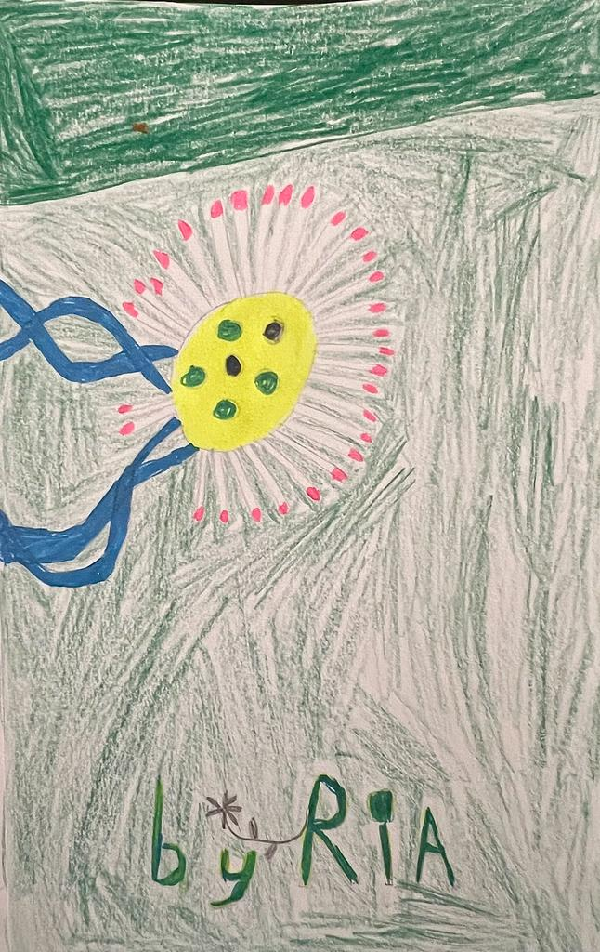
Common Daisy by Ivanka Roy ©
created on 27th April 2023

Contents

Bellis perennis – the Plant 3
Family – Asteraceae 3
Genus 3
Species Information 3
Habitat 4
Phytochemical Composition 5
Historical Uses in Traditional Medicine 7
Folklore & Mythology 10
The Deal with Bellis perennis 12
Remedy Comparisons & Differentiation 16
Arnica 16
Calendula 17
Ledum 18
Other remedies 19

Appendix 1: Organ Affinities 20
Appendix 2: Rubrics Degree 3 for Bellis p. 22
Appendix 3: Single Remedy Rubrics For Bellis P. 23

References 25

Bellis perennis – the Plant

Family – Asteraceae
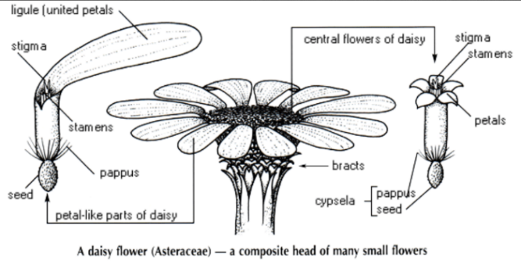
Bellis perennis, commonly known as the common daisy, is a species of flowering plant in the family Asteraceae. The family Asteraceae, also known as the daisy family or sunflower family, is one of the largest families of flowering plants, with over 32,000 known species.

Asteraceae plants typically have composite flowers, which means that each flower head is a cluster of many small flowers surrounded by bracts (modified leaves).

The flowers themselves are usually small and may be tubular, disc-shaped, or ray-shaped. The family includes many familiar garden flowers such as daisies, sunflowers, marigolds, and asters, as well as important food crops like lettuce and artichokes.

Genus
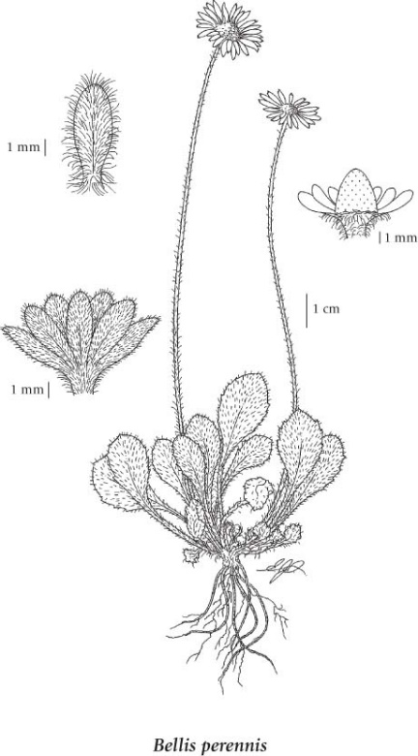
Bellis perennis is the type species of the genus Bellis, which contains between 11 and 26 species. The genus name Bellis comes from the Latin word "bella," meaning beautiful. Bellis perennis is a perennial herbaceous plant that can grow up to 25 centimetres tall. It is also known as the lawn daisy, English daisy, European daisy, or common daisy.

Species Information
General:
Perennial herb from a fibrous root.

Stem:
The stems of the daisy are firm and strong. They stand erect or have an upward curvature. Stems ascend to erect, are simple, leafless and hairy. Stems grow to a height of between 2 and 20 cms. The lower leaves on the stem are darker and fleshier than those that grow at the top. Each daisy stem bears leaves and a single flower at the tip. A stem may branch several times, and each branch will bear a flower. Daisy stems transport water and nutrients to the leaves and flowers.

Leaves:
Basal leaves with short to long stalks, the blades spoon-shaped to oval or orbicular, 0.7-3.0 (rarely 4.0) cm long, 0.5-2.5 cm wide, toothed to entire, obtuse to rounded at the tips, coarse, spreading-hairy above and below: stem leaves lacking.

Flowers:
Flower heads with ray and disk flowers, solitary; involucres 5-6 mm tall; involucral bracts egg-shaped to broadly oblanceolate, rounded to obtuse at the tips, sparsely hairy on the backs, often suffused with purple; receptacles cone-shaped; ray flowers 8-10 mm long, white to sometimes pink or purple; disk flowers yellow.

Fruits:
Achenes appressed-hairy, mostly 2-nerved, flattened; pappus lacking.

Roots:
Daisies have strong, vigorous root systems. The thick, deep fibrous roots enable them to seek out moisture below the soil's surface. Daisies are hardy perennials due in part to the strength of their root systems.

Pollination:
Pollinators are attracted to flowers by chemical and structural features. One of these structural features may the interaction of light with regularly arranged microscopic surface features. The ray florets of Bellis perennis have distinct microscopic furrows produced by cylindrical, transversely-striated cells. Under laboratory conditions these surface features produce diffraction patterns which may attract insect pollinators. However, under natural light conditions these effects are lost, indicating that such features are unlikely to attract the natural pollinators of Bellis. In Bellis, pollinators are likely to be attracted by the contrast between the capitulum's ray and tube florets.

Habitat
Bellis perennis is a perennial herbaceous plant that grows primarily in the temperate biome. It is commonly found in meadows, grasses, and lawns. The plant is also found in disturbed areas and coastal regions. It is a common plant in gardens and is often used as a ground cover. It is one of the commonest plants of close-cropped grassland in the British Isles, whether it is rabbit-grazed coastal turf or an urban lawn. On a summer's day, the change of a green lawn to one blotched with white within a few hours of dawn is a familiar sight. The transformation is due to the diurnal opening of the flower heads of the common daisy, whose name is derived from the Old English daeges eage ('day's eye). The flower heads (capitula) with their ring of white ray florets and central yellow tube florets are a delight to many people from mid-March until mid-October. Some flowering individuals are likely to be found even in the middle of winter.

Source: https://linnet.geog.ubc.ca/Atlas/Atlas.aspx?noTransfer=0&sciname=bellis+perennis

Phytochemical Composition

Bellis perennis contains a variety of bioactive compounds that are thought to contribute to its medicinal properties. These compounds include:

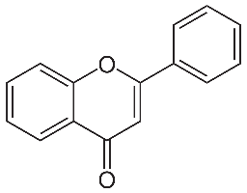
- Flavonoids: Flavonoids are a large group of polyphenolic compounds that are widely distributed in the plant kingdom. They are found in many fruits, vegetables, and herbs, and are responsible for the bright colours of many plant parts, such as the blue of blueberries, the red of strawberries, and the yellow of lemons. Bellis perennis contains several flavonoids, including luteolin, apigenin, and quercetin. These compounds have antioxidant and anti-inflammatory properties and may help to protect against cellular damage and inflammation.

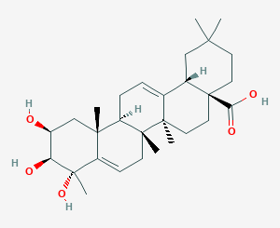
- Triterpenoids: Triterpenoids are a group of organic compounds that are derived from the 30-carbon precursor molecule squalene. They are widely distributed in the plant kingdom and are found in many medicinal herbs, fruits, and vegetables. Triterpenoids have a variety of biological activities and are known to have anti-inflammatory, antitumor, and immunomodulatory effects. They also have potential therapeutic applications for the treatment of conditions such as diabetes, cardiovascular disease, and Alzheimer's disease. Bellis perennis contains triterpenoids such as lupeol and α-amyrin. These compounds have been shown to have anti-inflammatory, analgesic, and antifungal properties.

- Saponins: Bellis perennis contains saponins such as bellidifolin and bellisperoside. Saponins are naturally occurring compounds that are widely distributed in all cells of legume plants. Saponins, which derive their name from their ability to form stable, soap like foams in aqueous solutions, constitute a complex and chemically diverse group of compounds. These compounds have been shown to have anti-inflammatory, antioxidant, and antifungal properties.

- Polysaccharides: Bellis perennis contains polysaccharides such as arabinogalactans and xyloglucans. These compounds have been shown to have immunomodulatory and wound-healing properties. One study published in the Journal of Medicinal Plants Research in 2011 analysed the polysaccharides extracted from Bellis perennis flowers and leaves using water extraction and found that they had significant antioxidant activity. The study also found that the polysaccharides exhibited a dose-dependent effect on scavenging free radicals and reducing oxidative stress.¹ Another study published in the Journal of Traditional and Complementary Medicine in 2019 analysed the polysaccharides extracted from Bellis perennis using an ultrasound-assisted extraction method. The study found that the polysaccharides had potent anti-inflammatory effects and could inhibit the production of pro-inflammatory cytokines in vitro.²

- Essential oils: Bellis perennis contains essential oils, which contribute to its characteristic aroma. The oil contains compounds such as eucalyptol, camphor, and alpha-pinene, which have antifungal, antibacterial, and anti-inflammatory properties. Even though, there is limited information on the essential oils present in Bellis perennis, as it is not commonly used for essential oil production; however, a few studies have analysed the chemical composition of the essential oil extracted from Bellis perennis and reported its potential biological activities. One study published in the Journal of Essential Oil Research in 2016 analysed the essential oil extracted from the flowers of Bellis perennis using hydro distillation and gas chromatography-mass spectrometry (GC-MS). The study identified 28 compounds in the essential oil, with the major components being α-pinene, limonene, and β-caryophyllene. The study also found that the essential oil exhibited moderate antioxidant activity.³ Another study published in the journal Molecules in 2018 analysed the essential oil extracted from the aerial parts of Bellis perennis using steam distillation and GC-MS. The study identified 31 compounds in the essential oil, with the major components being β-caryophyllene, germacrene D, and α-pinene. The study also reported that the essential oil had significant antibacterial activity against several bacterial strains.⁴

- Acids: Bellis perennis contains caffeic acid, ferulic acid, and chlorogenic acid, which have antioxidant and anti-inflammatory properties. There is limited information on the organic acids present in Bellis perennis. However, a few studies have analysed the organic acid composition of the plant and reported their potential biological activities. One study published in the Journal of Applied Sciences in 2006 analysed the organic acids present in the aerial parts of Bellis perennis using high-performance liquid chromatography (HPLC). The study identified several organic acids, including tartaric acid, malic acid, citric acid, and succinic acid. The study also reported that the organic acids had significant antioxidant activity.⁵ Another study published in the Journal of Food Science in 2010 analysed the organic acid composition of the leaves of Bellis perennis using HPLC. The study identified several organic acids, including citric acid, malic acid, fumaric acid, and succinic acid. The study also found that the organic acids had significant antimicrobial activity against several bacterial strains.⁶

These studies suggest that Bellis perennis may contain bioactive organic acids with potential therapeutic applications. However, more research is needed to fully characterize the organic acid composition of Bellis perennis and their biological activities.

Overall, the phytochemical composition of Bellis perennis is complex and varied, with multiple compounds that may contribute to its medicinal properties.

Historical Uses in Traditional Medicine

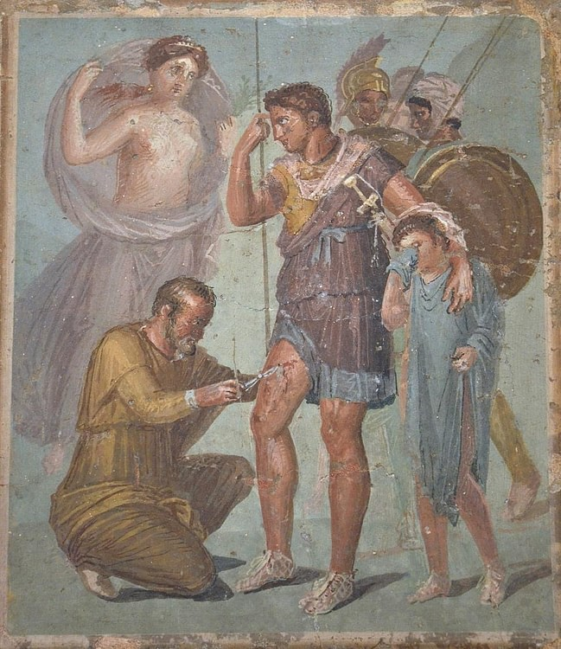
Fresco depicting Iapyx removing an arrowhead from Aeneas' thigh. Venus stands over while beside Aeneas stands his young son Ascanius. 1st century CE (between 45 and 79 CE), from Pompeii. (Naples National Archaeological Museum).

Source: https://www.worldhistory.org/image/3854/fresco-with-wounded-aeneas/

Ancient Greeks and Romans used Bellis perennis to treat wounds and inflammation. The Roman naturalist Pliny the Elder, who lived in the first century AD, wrote about the plant's use in his Natural History. Pliny recommended using Bellis perennis leaves and flowers in poultices for treating wounds and reducing inflammation. He also noted that the plant was commonly used in ornamental gardens and was known for its attractive, daisy-like flowers.

The Greek physician Dioscorides wrote about its use in his herbal guidebook, De Materia Medica. Dioscorides recommended using Bellis perennis leaves and flowers in poultices to soothe skin irritations, and he also noted the plant's use in treating bruises and wounds. In addition to its wound-healing properties, Bellis perennis was also used by the Greeks as a diuretic and to treat digestive disorders. It was believed to have a cooling and drying effect on the body, making it useful for reducing fevers and treating conditions such as diarrhoea. The Greek philosopher and naturalist Theophrastus also wrote about Bellis perennis, describing its use as a medicinal plant and noting its attractiveness as an ornamental flower.

Cover of an early printed version, Lyon, 1554
Source: https://en.wikipedia.org/wiki/De_materia_medica
In medieval Europe, Bellis perennis was commonly used by herbalists for a range of medicinal purposes. It was especially popular for treating wounds and bruises, and was believed to have anti-inflammatory and pain-relieving properties. One of the most famous medieval herbalists, Hildegard of Bingen, recommended Bellis perennis as a treatment for bruises and injuries, and also believed that it could be used to alleviate the symptoms of coughs and respiratory infections.

The use of Bellis perennis was often based on the concept of the "doctrine of signatures", which held that the appearance of a plant could indicate its therapeutic properties. For example, because the flowers of Bellis perennis resemble small eyes, the plant was believed to be beneficial for eye health and vision.

One of the most famous medieval herbalists, Nicholas Culpeper, recommended Bellis perennis for the treatment of wounds, bruises, and rheumatism. He also believed that the plant could be used to improve digestion and alleviate menstrual cramps.

Another important figure in medieval herbalism was Gerard of Cremona, who translated numerous Arabic medical texts into Latin. Gerard recommended Bellis perennis for the treatment of a range of ailments, including respiratory infections, kidney stones, and fever.

In addition to its medicinal properties, Bellis perennis was also used in medieval Europe for culinary and cosmetic purposes. The flowers were sometimes used as a natural food colouring and were also used to make perfumes and cosmetics. The leaves were sometimes used as a substitute for spinach and were believed to have a mild diuretic effect.

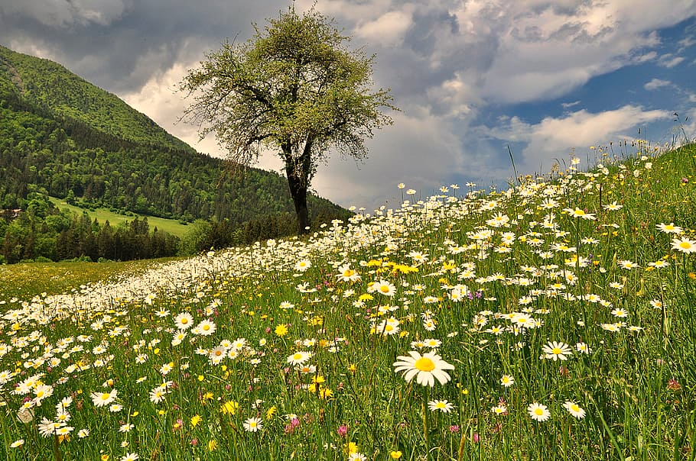

Folklore & Mythology

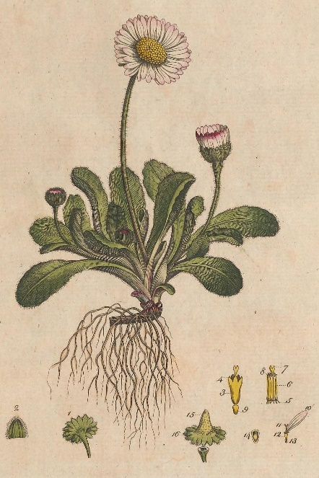
Bellis perennis
Pic source: https://herbaria.plants.ox.ac.uk/bol/plants400/profiles/ab/bellis
In Roman folklore, Bellis perennis was associated with several symbolic beliefs. For example, it was believed that carrying a sprig of Bellis perennis could ward off evil spirits and protect against the evil eye. In addition, the plant was sometimes associated with love and marriage.
According to one legend, the Roman goddess Venus was walking in a meadow when she saw Bellis perennis and was so struck by its beauty that she transformed it into a star. As a result, Bellis perennis became associated with the concept of "love's star" and was often used in love potions and charms.
In another Roman myth, Bellis perennis was said to have been created when the goddess Flora wept over the body of a beloved youth who had been killed in battle. Her tears fell to the ground and sprouted into daisy flowers, which became known as Bellis perennis. This story further cemented the plant's association with love and sorrow. Bellis perennis played a significant role in Roman folklore and was associated with various symbolic beliefs related to love, protection, and the supernatural.
In Greek mythology, Bellis perennis was associated with the goddess Aphrodite and the story of her lover Adonis. According to the myth, Adonis was a handsome young man whom Aphrodite fell in love with. However, Adonis was killed by a wild boar while hunting, and Aphrodite was overcome with grief. As her tears fell to the ground, they turned into small white flowers that became known as Bellis perennis. These flowers were said to be a symbol of Aphrodite's love for Adonis and her eternal sadness at his loss. In some versions of the myth, the flowers were also said to have grown where Adonis's blood fell, further emphasizing their association with his tragic death.

In another Greek mythology, Belides was a nymph who caught the eye of Zeus, the king of the gods. Zeus was notorious for his many love affairs, and he pursued Belides relentlessly. In order to escape his advances, Belides prayed to the gods to turn her into a flower. Her wish was granted, and she was transformed into the small, white flower that is now known as the common daisy or Bellis perennis. The name "Bellis" comes from the Latin word "bellus," which means "pretty" or "handsome." The name "perennis" means "everlasting" or "perennial," referring to the plant's ability to flower throughout the year. The story of Belides and Zeus has been retold in many different forms throughout history, and the daisy has become a symbol of purity, innocence, and true love. In some cultures, it is also associated with childbirth and motherhood.
Because of its connection to love and beauty, Bellis perennis was also often used in ancient Greek art and literature. It was a popular subject for poets and painters, and was often depicted in scenes of love and romance. The flower's small size and delicate petals were seen as a symbol of the fragility of love and the fleeting nature of beauty. The mythology surrounding Bellis perennis in ancient Greece added to its cultural significance and cemented its association with love, beauty, and tragedy.

According to the medieval legend, Bellis perennis was associated with the Holy Virgin Mary because the plant's white and pink flowers were believed to represent the Virgin's purity and compassion. The legend holds that the plant was created by the tears of the Virgin Mary, which fell to the ground and gave rise to the flowers.

The legend also states that Bellis perennis has protective powers that can help to ward off evil spirits and provide spiritual guidance. It was said that carrying a bouquet of Bellis perennis flowers could help one to feel closer to the Virgin Mary and to receive her blessings. The association between Bellis perennis and the Holy Virgin Mary is just one example of how the plant was revered and celebrated in medieval Europe for its spiritual and medicinal properties.

It is also often associated with motherhood and childbirth due to its association with the goddess of fertility and motherhood, Demeter. In Greek mythology, it is said that the daisy sprang from the tears of Demeter, who wept for her daughter Persephone, who was abducted by Hades to the underworld.

In Celtic folklore, the common daisy was known as the "fairy thimble" or "fairy cap." According to legend, fairies used the flower's tiny petals as a hat, which is how it got its name. The Celts believed that daisies had magical powers and could ward off evil spirits. They also associated the flower with the sun, and it was often used in Celtic rituals to promote fertility and prosperity.

In some Celtic traditions, it was said that placing a daisy under your pillow would bring about prophetic dreams. It was also believed that the flower had healing properties and could be used to treat wounds, fevers, and other illnesses. The daisy's association with fairies and magical powers has continued into modern times, and it is still considered a symbol of luck and good fortune in many parts of the world.
Painting: Knights in Armour Following a Girl with a Daisy Chain
Artist: Jacobs, Helen (1888-1970)

Pic source: https://www.bridgemanimages.com

The Deal with Bellis perennis

Bellis perennis has been traditionally used for its ability to heal bruises and injuries to deep tissue. This healing property can be seen as a parallel to the plant's resilience and ability to withstand damage to its own tissue, such as being trampled on or mowed over. In the same way that Bellis perennis can heal and regenerate its own damaged tissue, it can also aid in the healing and regeneration of human tissue. This may be due to the plant's phytochemical constituents, such as its triterpenoids and flavonoids, which have anti-inflammatory and antioxidant properties that may support tissue repair and healing. Overall, the plant's medicinal properties and its resilience in the face of physical damage can be seen as interconnected and reflective of the plant's ability to support healing and regeneration.

Bellis perennis is considered an invasive plant species in some regions due to its ability to quickly spread and take over areas. It has a high reproductive capacity and can tolerate a variety of environmental conditions, allowing it to establish and grow in many different types of habitats. This invasiveness can be compared to its medicinal properties as a healing agent for deep tissue injuries and bruises, where it is able to penetrate deeply and spread to promote healing. Just as Bellis perennis has a strong ability to spread and establish itself in new environments, it also has the ability to deeply penetrate and heal damaged tissues. This makes sense because the deeper tissues of the body are often more difficult to access and heal, just as invasive plants can be difficult to eradicate. Furthermore, Bellis perennis has been found to have a special affinity for the organs of the pelvis, such as the uterus and ovaries. These organs are also deeply located within the body and are often the site of long-standing, chronic issues.

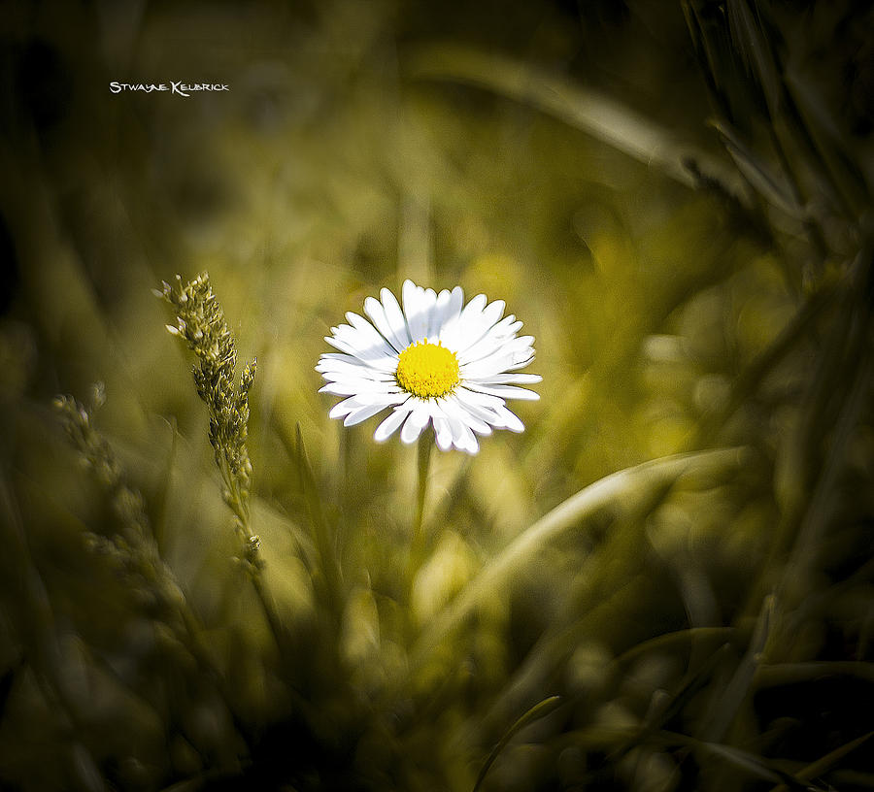
The daisy flower typically grows in open fields and meadows, often in large groups or clusters. However, despite its seemingly social nature, the plant is quite self-sufficient and can survive on its own. This could be seen as a reflection of the loneliness that some people may feel, even when surrounded by others. In homeopathy, Bellis perennis is sometimes used for emotional and mental symptoms related to loneliness and isolation, such as feeling disconnected from others or like an outsider. Once again, the plant's ability to thrive in open fields and meadows, where it may not always have immediate access to other plants or resources, could be seen as a reflection of the resilience and strength that can be cultivated in those who are able to endure feelings of loneliness and isolation. It is interesting that Bellis perennis typically has only one flower per stem. This solitude contrasts with many other plants, which may have multiple flowers on a single stem.

Bellis perennis is also known for its unique behaviour of opening and closing its petals in response to sunlight. The petals of the flower open in the morning sunlight, and close at night or in the absence of sunlight. This is known as nyctinasty, a process in which plants respond to the daily changes in light and temperature. Exposure to sunlight triggers the process of photosynthesis, which is necessary for the plant to produce food and energy. In addition to this, sunlight also plays a role in the production of pigments such as anthocyanins and carotenoids that give the flower its characteristic colours. Sunlight is also known to have an impact on the plant's overall growth and development, including stem elongation, leaf size, and flower production. However, excessive exposure to sunlight or heat can have adverse effects on the daisy plant. Prolonged exposure to high temperatures can cause wilting and damage to the flowers and leaves. In homeopathy, Bellis perennis is used as a remedy for the ill effects of exposure to cold after being overheated in the sun, which suggests that excessive sunlight can also cause certain symptoms that can be addressed with this remedy. This quality can be seen as a metaphor for its medicinal properties, which are thought to help open and heal blocked or stagnant energy in the body. In traditional medicine, it has been used to help treat conditions related to poor circulation and stagnation, such as bruises and wounds. Furthermore, this behaviour of opening and closing can be seen as a parallel to its organ affinities, particularly its effects on the cardiovascular system. The plant's ability to open and close in response to sunlight may reflect its affinity for helping to regulate blood flow and improve circulation. In terms of organ affinities, Bellis perennis is often associated with the female reproductive system, which is connected to the concept of fertility and the life-giving power of the sun. Additionally, Bellis perennis is thought to have a tonifying effect on the liver and digestive system, which are both associated with the body's ability to process and assimilate nutrients from the sun.

Bellis perennis has a unique ability to heal tumours that develop because of injuries or wounds. In homeopathy, it is often used to treat injuries that have not healed properly and may develop into tumours or nodules. Similarly, the small, unassuming flowers of the daisy plant hide a potent ability to heal and regenerate damaged tissue. The resemblance between the small size of the daisy flower and its ability to heal tumours is an interesting one. Just as the flower seems unassuming and simple, the remedy may not be the first one that comes to mind for tumour growth. However, the plant's resilience, as well as its ability to regenerate tissue, may be connected to its efficacy in treating tumours. In addition, the plant's affinity for healing injuries may also contribute to its ability to heal tumours. It can be said that tumours that develop as a result of injuries may be more likely to respond to Bellis perennis because of this affinity.

Bellis perennis is known to produce chemicals called allelopathic inhibitors that suppress the growth of nearby plants. These allelopathic chemicals are released into the soil from the roots of the daisy and can inhibit the growth of other plants in the area. Allelopathic chemicals work by interfering with the growth of other plants, either by inhibiting seed germination, reducing root or shoot growth, or affecting nutrient uptake. By producing allelopathic chemicals, Bellis perennis can regulate the growth of nearby plants and maintain control over its surroundings. This ability to self-regulate its surroundings through the production of allelopathic chemicals could be seen as a way of being fastidious, as Bellis perennis is able to maintain control over its environment and prevent the growth of competing plants. It also shines light upon the fact that Bellis perennis reacts strongly to any foreign energetic influence. There could also be issues of boundaries such as in cases of microbial infections.

Bellis perennis has been used as a homeopathic remedy for addressing physical and emotional trauma, such as injuries, bruises, and emotional shock or grief. This can be seen as a parallel to the theme of beauty with tragedy in folklore, as the daisy's delicate beauty is contrasted with the tragic stories associated with it. Similarly, Bellis perennis is used to help individuals who have experienced deep emotional wounds, such as grief or trauma, to heal and move forward. This can be seen as a similarity to the theme of beauty with tragedy in folklore, where the daisy's beauty is juxtaposed with the tales of heartbreak and loss. The plant's resilience and ability to thrive in difficult conditions may also be seen as a corresponding to the human capacity for healing and growth after experiencing adversity. Interestingly, the mythological stories surrounding Bellis perennis also feature themes of tragedy and grief. In Greek mythology, the nymph Belides was pursued by Zeus, and to escape him, she transformed herself into a daisy. Similarly, in Celtic folklore, the daisy is associated with death and the afterlife. The beauty of the plant, with its delicate white petals, serves as a symbol of hope and resilience in the face of tragedy, just as its medicinal properties offer comfort and support to those dealing with emotional pain and trauma.

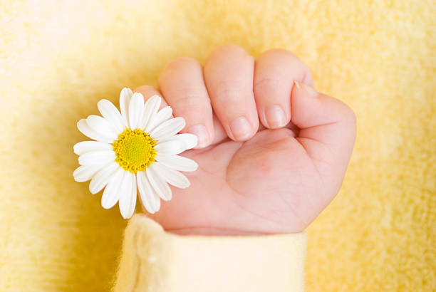
In terms of its botanical characteristics, daisy plants are known for their ability to self-seed and spread rapidly, indicating their fertility and abundance. This could be seen as the role of the daisy in traditional medicine for promoting fertility and addressing issues related to childbirth and motherhood. Additionally, the daisy's association with purity and innocence, as well as its use in bridal bouquets and wedding decorations, also suggests a connection to fertility and new beginnings. Furthermore, the resilient and adaptive nature of the daisy plant, as well as its ability to thrive in a variety of environments, could symbolize the strength and adaptability required for motherhood. In traditional medicine, Bellis perennis was also used to stimulate lactation in nursing mothers. It was believed that the plant's ability to increase milk flow was due to its astringent and stimulating properties. Additionally, the plant was used to address various menstrual and reproductive issues, such as irregular periods, cramps, and menopausal symptoms. In traditional folklore, the daisy was also believed to have protective properties for pregnant women and new-borns. It was said that carrying a daisy in your pocket during childbirth could help ensure a safe delivery and a healthy baby. Bellis perennis is considered a female remedy due to its affinity for the female reproductive system, especially the uterus and ovaries. It is often used in homeopathy to address various gynaecological issues such as menstrual irregularities, pelvic pain, and postpartum symptoms. Additionally, Bellis perennis is known for its ability to address physical and emotional trauma related to childbirth and pregnancy. It can also be beneficial for breast-related symptoms such as mastitis and soreness. In traditional herbalism, Bellis perennis was also used as a tonic for women's reproductive health and as a remedy for issues such as heavy menstruation and painful periods.

Bellis perennis has a particular affinity for the breasts and the pelvis, which are both areas located at the extremities of the body. This parallel could be seen in the way that the daisy plant grows close to the ground and its flowers are relatively small, indicating a focus on the lower extremities of the plant. Furthermore, the daisy flower's association with fertility and childbirth, as previously mentioned, involves the reproductive organs, which are also located at the lower extremity of the body.

Bellis perennis may be seen as a remedy that has a particular affinity for the lower parts of the body, including the extremities, which are associated with the reproductive system and the nurturing and protective aspects of femininity. Beauty and delicacy: Daisies are often associated with beauty, grace, and delicacy, all of which are traditionally associated with femininity. Fertility and reproduction: Daisies are often used in fertility and pregnancy rituals, and they are also believed to have properties that aid in reproductive health. This makes them a natural fit for women's health and femininity. In addition, the daisy's association with spring and the renewal of life further emphasizes its connection to fertility. The daisy's white petals, which symbolize purity and innocence, also tie into themes of fertility and new beginnings. Overall, the daisy plant's ability to grow, spread, and regenerate itself is a powerful symbol of fertility and the creative forces of nature. Nurturing and caregiving: Daisies are often seen as nurturing and caring flowers, which is also associated with the feminine role of caretaker and caregiver. The daisy plant's nurturing qualities can be seen in the way it grows in clumps, forming a protective ground cover that helps to retain soil moisture and prevent erosion. It grows and spreads, creating a blanket of flowers that protect and provide shelter for the surrounding plants and soil. It also attracts pollinators, providing a vital source of nourishment for them. Its ability to withstand a wide range of growing conditions, from harsh sun to cooler temperatures, also showcases its resilience and adaptability, which are important traits for nurturing and protecting both oneself and others. Additionally, the daisy's delicate and charming appearance can be seen as a reflection of the nurturing qualities often associated with femininity. Resilience and strength: Despite their delicate appearance, daisies are also known for their resilience and strength. This can be seen as a parallel to the strength and resilience of femininity in the face of adversity.

As a flower that is traditionally associated with femininity and motherhood, daisies may not seem to have much to do with masculinity. However, in some cultures, daisies have been associated with traits like strength, courage, and resilience - traits that are often associated with masculinity. For example, in Norse mythology, the daisy was associated with the god Baldur, who was known for his strength and bravery. The daisy was said to have grown from his tears after his death and became a symbol of his strength and resilience. In addition, some people believe that the daisy can help to promote feelings of inner strength, courage, and confidence - qualities that are often associated with masculinity. While the daisy is perhaps best known for its associations with femininity and motherhood, it can also be seen as a symbol of strength and resilience, qualities that are important to people of all genders. Also, some sources suggest that the daisy may have been associated with masculinity in Celtic folklore, where it was considered a symbol of the warrior. In this context, the daisy's white petals may have been seen as representing purity and bravery, while the yellow centre was seen as symbolizing the sun, which was associated with masculine power. Additionally, daisy's association with childbirth and motherhood could also be seen as indirectly related to masculinity, as men may play a role in supporting and protecting their partners during these processes.

Remedy Comparisons & Differentiation

Arnica
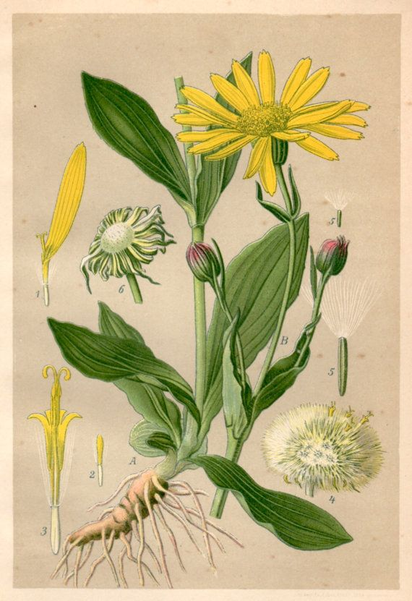
In homeopathy, remedy differentiation is an important aspect of selecting the appropriate remedy for a particular case. When comparing Bellis perennis and Arnica, there are several key differences that can help in making the best choice for a particular individual.

One of the main differences between the two remedies is the type of trauma or injury they are best suited for. Arnica is most used for acute injuries, such as bruising or trauma from a fall, where there is a lot of soreness and inflammation. Bellis perennis, on the other hand, is better suited for injuries that are more chronic or ongoing, such as muscle strain from repetitive motion.

Another important factor to consider when choosing between the two remedies is the location of the pain. Arnica is often used for injuries that affect the entire body, such as those that result from a fall or accident. Bellis perennis, on the other hand, is often used for injuries that are more localized, such as those that affect the chest or abdominal area.

In terms of the quality of pain, Arnica is typically indicated for injuries that are sore, bruised, and sensitive to touch. The pain is often described as being as if the affected area has been beaten or pounded. Bellis perennis, on the other hand, is often used for injuries that are duller and achier, with a sensation of being sore and bruised.

In cases where the pain is worse from touch or motion, Arnica is often the remedy of choice. The patient may describe the pain as feeling sore, bruised, or beaten, and the affected area may be swollen or discoloured. Bellis perennis, on the other hand, is often indicated in cases where the pain is worse from cold, damp weather or exposure to cold water. The patient may describe the pain as a dull ache or soreness that is worse from movement, and there may be a sensation of stiffness or cramping in the affected area.

In terms of the physical symptoms, Arnica is often indicated for injuries that are acute and accompanied by significant inflammation and bruising. The affected area may be hot to the touch, and there may be a sensation of throbbing or pulsing pain. Bellis perennis, on the other hand, is often used for injuries that are more chronic or ongoing, such as repetitive strain injuries or chronic back pain. The pain may be described as a dull ache or soreness that is worse with movement or exertion, and there may be a sensation of stiffness or tightness in the affected area.

Finally, the mental and emotional state of the patient can also be a factor in choosing between these two remedies. Arnica is often used for patients who are in shock or feeling overwhelmed by their injury or trauma, while Bellis perennis is more commonly used for patients who are experiencing a sense of frustration or irritation due to their injury or ongoing pain. Arnica patients may be restless, anxious, or fearful, and may have difficulty sleeping or concentrating. Bellis perennis, on the other hand, is often indicated for patients who are feeling irritable or frustrated due to their ongoing pain or discomfort. They may feel stuck or unable to move forward in their lives and may be prone to feelings of anger or resentment.

There are some interesting parallels between the clinical applications of Bellis perennis and Arnica, and their habitat and botanical characteristics. Bellis perennis, commonly known as the common daisy, is a perennial herb that grows in meadows and grasslands throughout Europe and other parts of the world. It has small, white or pink flowers with yellow centers, and is often considered a weed due to its ability to thrive in a wide range of environments.

From a clinical perspective, Bellis perennis is often used to treat injuries or strains that result from overuse or repetitive motion, such as those that might be experienced by a person working in a physically demanding job or participating in sports or other strenuous activities. This is interesting to consider in light of the plant's ability to thrive in a wide range of environments, suggesting a certain robustness or resilience that may be reflected in its clinical applications.

Arnica, on the other hand, is a perennial herb that grows in mountainous regions throughout Europe and other parts of the world. It has bright yellow flowers and grows in rocky, well-drained soils. From a clinical perspective, Arnica is often used to treat acute injuries or trauma, such as those that might be experienced in a fall or other accident.

Overall, the parallel between the clinical applications of Bellis perennis and Arnica and their habitat and botanical characteristics suggests that there is a certain wisdom or intelligence inherent in the natural world, with plants evolving to thrive in specific environments and developing therapeutic properties that are uniquely suited to the needs of humans and other animals. By studying and understanding these connections, we can gain a deeper appreciation for the healing power of nature.

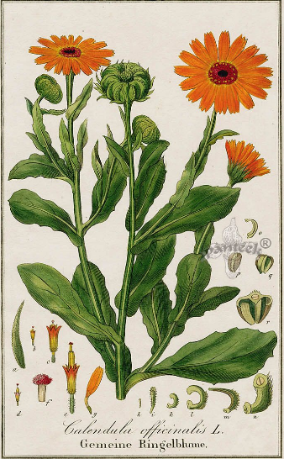
Calendula
Calendula is an annual plant that completes its life cycle within a single year. This characteristic is reflected in its medicinal uses, where it is often used for acute conditions, such as injuries or infections, that develop quickly and have a relatively short duration. Calendula typically grows to a height of 12-24 inches (30-60 cm). The flowers of Calendula are typically bright orange or yellow, although some varieties may have pink or white flowers. They have a central disk that is dark in color and surrounded by numerous petals. The flowers bloom in the summer and fall months. Calendula has dark green leaves that are arranged alternately on the stem. They are typically lance-shaped (rubric- injuries, lacerations) and have a slightly fuzzy texture.

Indications: Calendula is often used for its wound-healing and anti-inflammatory properties, particularly for skin irritations and infections. Bellis perennis is used for its anti-inflammatory effects on the muscles and joints, particularly after injuries or traumas.
Physical symptoms: Calendula is indicated for superficial wounds that tend to be red, inflamed, and painful, with a tendency to bleed easily. Bellis perennis is indicated for deep muscle and joint soreness, with a bruised or aching sensation.

Ledum
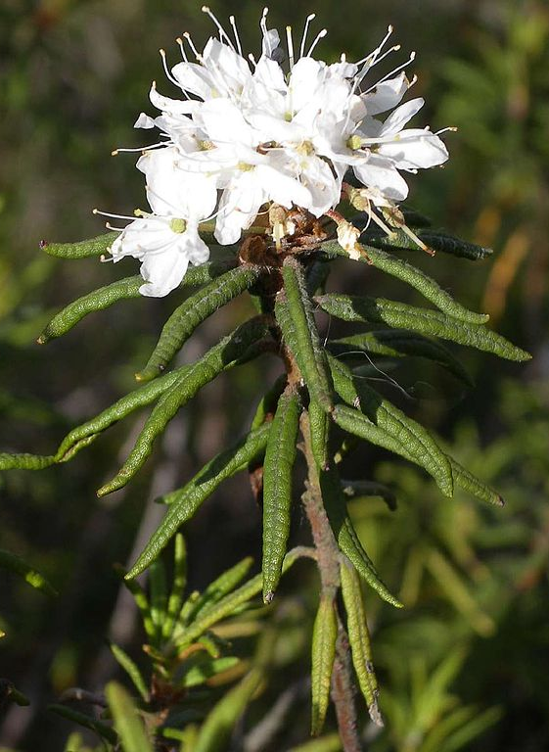
Bellis perennis is often used to treat injuries or strains that result from overuse or repetitive motion, such as those that might be experienced by a person working in a physically demanding job or participating in sports or other strenuous activities. The pain associated with Bellis perennis is typically described as sore and bruised and may be accompanied by stiffness or aching in the affected area. This type of pain may be worsened by cold and damp weather. Ledum, on the other hand, is often used to treat injuries that result from puncture wounds or other types of traumas, such as a sprain or strain. The pain associated with Ledum is typically described as sharp or shooting, and may be accompanied by swelling, bruising, or discoloration. This type of pain may be worsened by warmth and may be relieved by cold applications.

From a botanical perspective, Bellis perennis and Ledum have some interesting differences as well. Bellis perennis is a perennial herb that grows in meadows and grasslands throughout Europe and other parts of the world. It has small, white or pink flowers with yellow centers, and is often considered a weed due to its ability to thrive in a wide range of environments. Ledum, on the other hand, is a small, evergreen shrub that grows in boggy, acidic soils in the northern hemisphere. It has tiny, white or pink flowers and is often used as an ornamental plant in gardens.

Ledum’s flowers and leaves have a strong aroma that is often described as resinous or turpentine-like. This is due to the high concentration of essential oils in the plant, which are believed to have antiseptic and anti-inflammatory properties. In homeopathy, Ledum palustre is often used to treat skin conditions such as acne, eczema, and rashes, which may be caused or exacerbated by bacterial or fungal infections. Ledum is a hardy plant that can survive in harsh, cold environments. In homeopathy, it is sometimes used to treat conditions that are associated with coldness, such as cold hands and feet or chills. It is also used to treat conditions that are worsened by cold, such as arthritis or joint pain. The plant's leaves are small and needle-like, with a dark green colour that helps them to absorb sunlight. In homeopathy, Ledum palustre is sometimes used to treat eye conditions such as cataracts or macular degeneration, which may be related to a lack of sunlight or poor absorption of nutrients. Ledum palustre is a member of the Ericaceae family, which also includes plants such as blueberries and cranberries. Like these other plants, Ledum palustre is high in antioxidants, which are believed to have a variety of health benefits.

Bellis perennis may be more appropriate for sore, bruised pain that results from overuse or repetitive motion, while Ledum may be more appropriate for sharp, shooting pain that results from trauma or puncture wounds.

In Synthesis repertory, there are only two remedies, Extremities, Coldness after injuries- Bellis p. and Ledum.

Bellis perennis is indicated for cold extremities that feel numb and painful, as if they have been bruised or beaten. This coldness may be accompanied by stiffness and aching and may be worse in damp or cold weather. The patient may also experience a sensation of weight or heaviness in the affected area. Ledum, on the other hand, is indicated for cold extremities that feel icy cold and numb, with a sensation of pricking or tingling. This coldness may be accompanied by swelling, especially in the ankles and feet, and the affected area may feel better with cold applications.

For Bellis perennis, the coldness in the extremities is typically worse in cold and damp weather. The patient may also feel better with warmth and movement, as this helps to increase circulation and relieve stiffness and aching. For Ledum, the coldness in the extremities is typically worse with warmth and better with cold applications, such as ice or cold compresses. The patient may also experience swelling and discoloration, which may be improved by cold applications.

Other remedies
Bellis perennis may be considered in between Arnica Montana and Echinacea angustifolia. It embraces somewhat the field of Echinacea angustifolia for example acne, boils, acrid pus and fatigue. Arnica Montana corresponds to contusions more; Rhus toxicodendron to superficial sprains limited to muscles, Bellis perennis, to deep muscular sprains, Conium maculatum to bruises of mammae, Cimicifuga racemose to belly muscles, Vanadium Metallicum to brain softening and degenerative states and Calendula officinalis to lacerations. Bellis perennis is limited to soreness, two deeper muscles, overworked, venous congestion, senile, rheumatic and fagged persons. Complaints due to cold food and cold wind.

Appendix 1: Organ Affinities

Organ affinities are determined by a variety of factors, including the symptoms that a remedy is known to address, as well as the physical and chemical properties of the remedy itself. Bellis perennis is known to have affinities for several organs and systems in homeopathy. Here is a brief of the organ affinities and their corresponding rubrics.

Muscles and soft tissues
Bellis perennis has a strong affinity for the muscles and soft tissues and is commonly used for injuries and traumas affecting these areas.
- Injuries, general, contusions, bruises
- Injuries, general, sprains
- Injuries, general, strains
- Back, pain, sacrum, sprains, and strains
- Extremities, pain, hip, sprains, and strains

Figure: Soft tissues located across the human body. Reproduced from [3]. CC BY 4.0
https://www.researchgate.net/figure/Soft-tissues-located-across-the-human-body-Reproduced-from-3-CC-BY-40_fig1_354955004

Joints
Bellis perennis is also indicated for joint pain and stiffness, especially in the hips and lower back.
- Extremities, pain, rheumatic
- Extremities, pain, sore, bruised, as if beaten
- Extremities, stiffness, rheumatic
- Extremities, swelling, joints
- Extremities, weakness, rheumatic

Female reproductive system
Bellis perennis is often used to treat menstrual problems, such as heavy bleeding, painful cramps, and irregular cycles.
- Female, bleeding, heavy
- Female, pain, uterus, menses, during
- Female, sexual organs, tumours, fibroids

Digestive system
Bellis perennis is sometimes used to treat digestive problems, such as indigestion, bloating, and gas.
- Stomach, fullness, eating, after
- Stomach, indigestion, food, after
- Stomach, nausea, eating, after
- Rectum, constipation

Respiratory system
Bellis perennis may also be helpful for treating respiratory infections, such as colds, flu, and bronchitis.
- Chest, pain, coughing, while
- Chest, pain, coughing, expectoration, with
- Chest, congestion

Urinary system
Bellis perennis can also be used to treat urinary tract infections and other urinary system disorders.
- Bladder, pain, urination, before
- Bladder, pain, urination, after
- Bladder, urgency, frequent

Appendix 2: Rubrics Degree 3 for Bellis p.
Here is a list of rubrics that have Bellis perennis in Bold in the Synthesis repertory:

Appendix 3: Single Remedy Rubrics For Bellis P.

Boericke Repertory
- FEMALE SEXUAL SYSTEM - Menopause, climacteric period; change of life - Fatigue - persistent tiredness, fagged womb: (1) bell-p.
- FEMALE SEXUAL SYSTEM - Complaints during pregnancy - Weariness in limbs, cannot walk: (1) bell-p.

J. Clarke Clinical repertory
- Clinical - E - exudations: (1) bell-p.
- Clinical - O - over-work: (1) bell-p.
- Clinical - R - railway spine: (1) bell-p.
- Clinical - S - stasis: (1) bell-p.
- Clinical - U - uterus - fatigued: (1) bell-p.
- Causation - cold - drinks, when overheated; effects of: (1) bell-p.
- Causation - over-heated - wet, getting, when: (1) bell-p.
- Causation - wet - overheated, when: (1) bell-p.

S. Phatak Concise Repertory
- D - Drinks - cold - agg, when over heated: (1) bell-p.
- I - Injuries, shocks, wounds, bruises, etc - deep: (1) bell-p.
- I - Injuries, shocks, wounds, bruises, etc - pelvic organs, of: (1) bell-p.
- O - Oedema - injury, after: (1) bell-p.
- V - Veins - varicose: (1) bell-p.
- W - Walking - inability - pregnancy, during: (1) bell-p.
- W - Wrists - contracted, as if: (1) bell-p.

F. SCHROYENS SYNTHESIS Treasure Edition 2009V
- FACE - ERUPTIONS - acne - wet cold - agg.: (1) bell-p.
- FACE - ERUPTIONS - eczema - weeping: (1) bell-p.
- MOUTH - PAIN - Tongue - eating - agg.: (1) bell-p.
- MOUTH - PAIN - Tongue - eating - agg. - burning: (1) bell-p.
- MOUTH - PAIN - Tongue - talking agg. - burning: (1) bell-p.
- STOMACH - PAIN - constriction - amel.: (1) bell-p.
- STOMACH - VOMITING - apples; after: (1) bell-p.
- ABDOMEN - DISTENSION - fat food; after: (1) bell-p.
- ABDOMEN - INJURY - deep tissue: (1) bell-p.
- ABDOMEN - INJURY - Pelvic organs: (1) bell-p.
- ABDOMEN - PREGNANCY - during - agg. - External abdomen: (1) bell-p.
- ABDOMEN - RUMBLING - stool - amel.: (1) bell-p.
- FEMALE GENITALIA/SEX - ATONY OF UTERUS - pregnancy; in: (1) bell-p.
- FEMALE GENITALIA/SEX - DELIVERY - after; complaints - injuries of parts - Soft tissues; of the - accompanied by - swelling: (1) bell-p.
- FEMALE GENITALIA/SEX - LEUKORRHEA - delivery; after: (1) bell-p.
- FEMALE GENITALIA/SEX - PAIN - Uterus - accompanied by - Back; pain in: (1) bell-p.
- COUGH - RAWNESS: (1) bell-p.
- EXPECTORATION - DEFICIENT: (1) bell-p.
- CHEST - CANCER - Mammae - accompanied by - ulcers - tubercular ulcers: (1) bell-p.
- CHEST - HEART; COMPLAINTS OF THE - motion; after slightest - amel.: (1) bell-p.
- CHEST - PAIN - cough - during - agg. - sticking pain: (1) bell-p.
- EXTREMITIES - PAIN - rheumatic - massage - amel.: (1) bell-p.
- EXTREMITIES - PAIN - rheumatic - motion - amel. - violent motion: (1) bell-p.
- EXTREMITIES - PAIN - Upper arms - Deltoid - warmth - amel. - heat amel.: (1) bell-p.
- EXTREMITIES - VARICES - pregnancy; of: (1) bell-p.
- EXTREMITIES - WALKING - difficult - pregnancy; during: (1) bell-p.
- EXTREMITIES - WEAKNESS - gout, after: (1) bell-p.
- SKIN - ERUPTIONS - liver spots: (1) bell-p.
- SKIN - ERYSIPELAS - inflamed: (1) bell-p.
- SKIN - PAIN - biting pain: (1) bell-p.
- GENERALS - CANCEROUS AFFECTIONS - Blood vessels: (1) bell-p.
- GENERALS - DROPSY - external dropsy - injuries; after: (1) bell-p.
- GENERALS - FOOD AND DRINKS - cold drink, cold water - agg. - perspiring; when: (1) bell-p.
- GENERALS - INJURIES - operation - ailments from - deeper tissues and after major surgical work; to: (1) Bell-p.
- GENERALS - INJURIES - Nerves - cold bathing agg.: (1) bell-p.
- GENERALS - PAIN - rheumatic - Nerves: (1) bell-p.
- GENERALS - PULSE - extrasystoles: (1) bell-p.
- GENERALS - STASIS OF THE VENOUS SYSTEM - mechanical causes; from: (1) bell-p.
- GENERALS - TUMORS - congestive: (1) bell-p.

References

- J. Medicinal Plants Res. 2011, 5(10), 1954-1960. Title: Antioxidant activities of the polysaccharides isolated from the flowers and leaves of Bellis perennis L. DOI: 10.5897/JMPR11.170
- J. Tradit Complement Med. 2019 Jan 29;9(1):56-63. Title: Ultrasound-assisted extraction of polysaccharides from Bellis perennis L. and its anti-inflammatory activity in vitro. DOI: 10.1016/j.jtcme.2018.12.005
- J. Essent. Oil Res. 2016, 28(5), 462-468. Title: Chemical Composition and Antioxidant Activity of Essential Oil from the Flowers of Bellis perennis L. from Kosovo DOI: 10.1080/10412905.2016.1165617
- Molecules. 2018 Sep 28;23(10):2475. Title: Essential Oil Composition and Biological Activities of the Aerial Parts of Bellis perennis L. Growing Wild in Romania DOI: 10.3390/molecules23102475
- J. Appl. Sci. 2006, 6(13), 2871-2876. Title: Antioxidant Activity of Organic Acids from Leaves and Flowers of Bellis perennis L. DOI: 10.3923/jas.2006.2871.2876
- J. Food Sci. 2010, 75(6), M348-M353. Title: Organic Acid Composition of Leaves of Bellis perennis L. and Their Antimicrobial Activity DOI: 10.1111/j.1750-3841.2010.01681.x

A composite flower by Ivanka Roy ©

