**Mistletoe (Viscum Album)**

*‘Convulsion, Constriction, Congestion, Cancer’*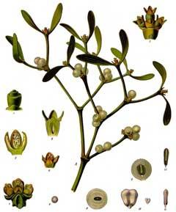

**Index**

**Introduction to the plant**

**and it’s uses and traditions**: 3

**Use in cancer treatment:**  4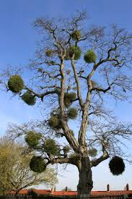

**Mistletoe therapy:** 6

**Phytochemical composition:** 6

**Historical uses in traditional medicine:** 7

**Early medicinal use:** 7

**Mistletoe herb:** 7

**Clinical:** 8

**Place as a homeopathic remedy:** 8

**Case examples:** 10

**Poisoning**: 11

**Provings:** 11

**Key Remedy themes:** 14

**Symptom table at a glance:** 15

**Remedy comparison/differentiation:** 18

**Final comments:** 22

**Rubric index:** 23

**References:** 32

**Bibliography:** 33

**Rubric Appendix** 34

**Introduction to the plant and it’s uses**:

Mistletoes are parasitic plants that grow on trees. They cannot grow on their own. The British species grows over much of northern central Europe and has the name viscum (sticky white-viscous) album (berries-albus). The colloquial name ‘mistletoe’ is thought to be derived from the Anglo-Saxon words Mistel and Tan, meaning dung and twig or ‘dung-on-a-twig’. Indeed, this is how mistletoe can grow out of bird droppings on a branch. (Briggs, 2020).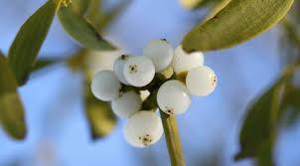

Mistletoe is widely known as the plant which represents romance, fertility and vitality, think of the Christmas tradition of a kiss under the mistletoe. It has been used medicinally for hundreds of years and prescribed for both livestock and humans for numerous contradictory reasons, many relating to fertility. Traces of mistletoe were found in the stomach of the preserved, 1st century, bog body of ‘Lindow man’ recovered from a bog in Cheshire in 1984. It is unknown why the berries were there, either eaten as a poison or for medicinal reasons, it does however tell us that the plant has been harvested and used for many centuries. (Briggs, 2020)

Viscum album is the species of mistletoe which grows in Britain and the Northern hemisphere and belongs to the Loranthaceae group of plants. This group of flowering plants are semi parasitic and live on tree branches. They contain chlorophyll meaning they can photosynthesise to make their own sugars. After germination, a modified root penetrates the bark of the host tree and forms a connection through which water and nutrients pass from host to parasite to host. They are slow growing but persistent: their natural death is determined by the death of the host.

Mistletoe can grow on a wide variety of host trees, favouring apple, limes, poplars, hawthorns, maples and willows. They thrive in an ‘open’ habitat where their host is unshaded by other trees. (RHS 2024)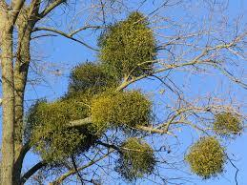

Mistletoe forms a drooping, yellowish evergreen bush, 60-90 cm long on the branch of a host plant. It has thickly crowded forking branches with oval to lance-shaped leathery leaves about 5cm long. These leaves are arranged in pairs, each opposite each other on the branch. These apparently simple leaves are continuously repeated, systematically building up to near perfect spheres. During winter these remain green against the bare, host tree, tree branches. The plant does not damage the tree and retains its own order and structure.

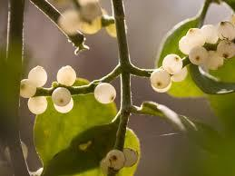

**Use in cancer treatment:**

Mistletoe extracts are one of the most widely studied complementary and alternative medicine therapies for cancer, to the extent that it is now offered to patients suffering from certain types of cancer on the NHS. (bodymindinsights.co.uk 2024).

It is generally thought that cancer is malignant and a result, not of an error in a single cell, but an illness emerging from the organism as a whole. Unlike mistletoe, cancer becomes autonomous from the whole (body) and the more progressed the cancer, the more tissue differentiation is lost and the more existing boundaries are violated. (Mulder, 2009).

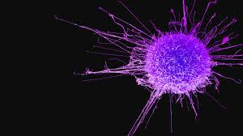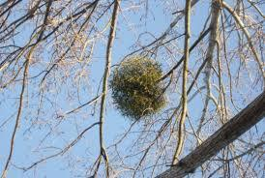

The images below show the mistletoe much like the x-ray of a cancer patient and metastic growth, but unlike the cancer the mistletoe is well organised and structured. Looking at this through the eyes of the ‘Doctrine of Signatures’, it could reveal both the image of malignant growth, and of it’s healing. (The Homeopath, 2009).

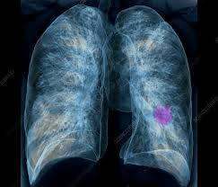

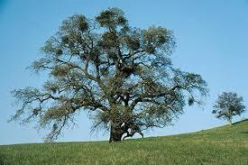

**Mistletoe therapy:** 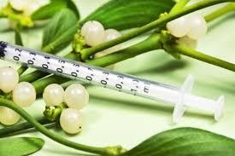

Mistletoe cancer therapy has been used for cancer care since the 1920’s. It has an immunomodulatory effect on the immune system-neither overstimulating nor suppressing it but helping it to work more efficiently. Mistletoe has been shown to induce cancer cell death both directly by being toxic to them and indirectly by supporting the immune cells. It influences white blood cells, which are part of the immune system that engage in finding cancer cells. Mistletoe can also limit cancer’s ability to spread, and it can help stabilize and repair DNA. (Mulder, 2009). ‘Mistletoe extract is a semi-parasitic plant with several active ingredients that, in preclinical studies, appear to directly cause the death of tumor cells and stimulate an immune response’. (hopkinsmedicine, 2023).

Rudolph Steiner introduced the concept of ‘warmth organisation’ within the anthroposophic medical theory. Where temperature is closely linked to the immune system and plays a key role in overcoming illness. Mistletoe preparations, when injected into cancer patients subcutaneously or intravenously has a warming effect on the body and swelling. Fever has thus become recognised as one of the key facilitators of the immune response. (Mulder, 2009)

**Phytochemical composition:**

Mistle comprises of two main groups of toxins – the viscotoxins and the mistletoe lectins. The actions of viscotoxins are closely related to snake venoms. Viscotoxins has a dissolving action and lectins have growth inhibiting properties. (Mont, 2010)

A 2023 study of John Hopkins University showed ‘it’s intravenous extract use’ to ‘be a good adjunct to mitigating side effects of many orthodox cancer treatments. (hopkinsmedicine, 2023).

**Historical uses in traditional medicine:**

Mistletoe has long had a magical and sacred status. The Druids would collect mistletoe as part of their celebration of the winter solstice. The ancient Greeks considered the plant to be sacred and several mythologies from around the world include it in their myths. It was Frigga, the goddess of love who made it into a symbol of peace and love. This tradition continues in many European countries at Christmas, where mistletoe is pinned up in doorways and seen as a kissing bough and a symbol of love, joy and merriment. (Brigg,2020)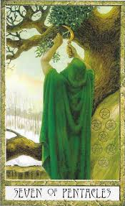

**Early medicinal use:**

The leaves and young twigs would historically be gathered and dried before fruiting, the powdered and often given in the form of tea. It was used to treat a wide range of ailments, but acquired a special reputation as being a cure for 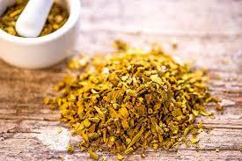

‘falling disease’ or epilepsy. Grieve in 1682 extolled the benefits of mistletoe in treating epilepsy. These treatments became very popular and mistletoe become the go-to medicine for a variety of conditions effecting the nervous system. Mistletoe was also prescribed for it’s hyposensitive and diuretic properties. The most toxic part of the plant was found to be the berries, so they were used topically to treat tumours. (Mont, 2010)

**Mistletoe herb:**

Mistletoe tea can be purchased to help support the cardio-vascular system and the herb can be bought in tincture form to treat medical conditions such as epilepsy, asthma, hypertension, headaches, menopausal symptoms, infertility, dermatitis, arthritis and rheumatism. 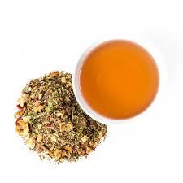

**Clinical**

Cancer, chorea, epilepsy.

Aura epileptica. Chorea. Deafness. Dysphagia. Endometritis. Epilepsy. Labour, slow. Levitation. Lumbago. Menorrhagia. Metrorrhagia. Orchitis. Otalgia. Otorrhoea. Ovaritis. Retained placenta. Sciatica. Spleen pain in. Struma. Throat, sore. Whooping-cough. (Clarke, 1902)

It is also effective in neuralgia of a gouty nature. " Dr. Ivatts reports of a case of rheumatism, in an old man with pains in the wrist, ankle, knuckle-joints and back”. The next important action of the remedy is on the female generative organs, especially the womb. It is also a remedy for chronic or periodical haemorrhages in menopause. (Ivatts, 1876)

Murphy confirms the picture writing that Viscum Album ‘affects the nerves and female sexual organs. Lowers blood pressure. Dilates blood vessels, slows pulse due to the central irritation of the vagus nerve. Rheumatic and gouty complaints, neuralgia especially sciatica. Epilepsy, chorea, metrorrhagia, general tremor, rheumatism- tearing pain. Congestion in head with headaches and vertigo. Blood not clotting and wounds not healing. Rheumatic deafness. Asthma. (Murphy, 2021)

**Place as a homeopathic remedy:** 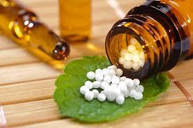

As has been said previously mistletoe was highly revered by the priestesses of the druids as a sacred healing plant. They discovered its undoubted healing qualities, especially in gout, rheumatism, nerve pains of various kinds, neuralgias, as well as of its close affinity with and influence upon the female sexual system.

It was Dr. W. Huber who was at the time a physician to the Homoeopathic Hospital of the "Sisters of Mercy" in Austria (1857) who researched and proved the remedy on himself and other people leading to a much better understanding of the remedy. He believed in it’s many healing properties and used it regularly in the hospital. According to Dr. Huber. the symptoms of Viscum album are similar to those of Aconite, Bryonia, Pulsatilla, Rhododendron, Rhus and Spigelia: other major anti-arthritic and anti-rheumatic remedies. Viscum has symptoms in common with each of these remedies, and is thus particularly useful in gouty and rheumatic complaints, in acute as well as in chronic cases. Tearing pains is a significant sensation in the remedy, wherever they appear in the body. He continues on to say that it follows well after Aconite in acute rheumatism. It is also very effective in different neuralgias of a gouty or rheumatic origin, as in ischias (sciatica), prosopalgia (facial pain), periostitis (tissue around bones pain), and especially in earache-tearing pains in the ears, and otitis. It is a valuable as a remedy in rheumatic deafness. A causation could be high winds, i.e., all gouty, rheumatic or other ailments which, similarly to Rhus and Rhodedendron, are aggravated by sharp north or northwest winds. For this reason Viscum is more often applicable in the colder season than in summer, or at time when gouty or rheumatic affections or pains are usually aggravated. It has also been found beneficial in asthmatic complaints if connected with gout or rheumatism.

Viscum Album is indicated in menopausal haemorrhages and is found to stimulate slow labour and helps to expel the placenta.

**(Anshutz, 2002)**

***Miasm***: psoric

***Causations*:** chill, wetting. Fright. Suppression of menses.

**Case examples:**

Below are a couple of real case examples where Viscus album proved useful. I have selected a case where involving rheumatism and a case which involves labour. Both of these areas are highlighted as key areas in the remedy.

**Case 1:**

Hom. World, 1876, by Dr. Ivatts.

‘October 24, 1875.-T. H.-,aged about fifty. Rheumatism of ankle, for the last six years wrists, and knuckle joints, also pains across the lumber muscles.

Extreme distress on motion, with weariness and pain. Great pain in walking.

Worse on commencing to move, but after continuing the movement for a time the pain diminishes. No pain when at rest except when warm in bed, when the ankle and wrist joints are occasionally very bad.’

Has stopped work and travelled abroad.

‘Could never get relief from the rheumatism-Viscum album No. 1, five drops twice a day. November 14-After taking medicine for ten days the weary feeling gradually diminished, and the muscular motion became free from distress. Has now continued medicine for three weeks, and he says, "I am quite free from rheumatic pains". February 18, 1876-Saw patient today, and he tells me he has continued quite free from the rheumatic pains since November’.

(Dr. Ivatts, 1876)

**Case 2:**

Dr. E. M Holland wrote the following case in Medical Summary 1898.

‘My first case of child birth in which I used Mistletoe (Viscum album) was May 30, 1897. Was called to see Mrs. C,; second confinement; there was but little advancement; I sent the husband to my office, three blocks away, for some Mistletoe, and I gave the lady half a teaspoonful with a swallow of water every twenty minutes, and before an hour had passed labour was on in good shape, and in half an hour all was over. The placenta came readily and everything progressed well after birth.’ (Vision, miccant 2024)

**Poisoning**:

Two women took the drug and every muscle of the body was paralyzed, including bowels, apart from those of the eye. Both died on the 8th and 9th day, starved to death.

A boy of 14, ate some berries and soon after felt giddy and became insensible. Lips livid, conjunctiva injected, pupils slightly dilated and fixed, pulse slow and full, bounding, breathing slowly, stertorous (noisy and laboured). Drew up his feet when pricked and came round with cold applications. Spoke incoherently, had spectral illusions and was inclined to be violent. 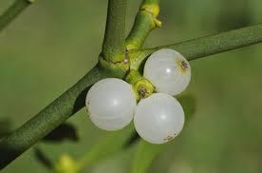

**Provings:**

The first homeopathic symptomatology was established by Proll, Stager, Schier and Black during the second part of the 19th century, using the mother tincture and low potencies.

Dr. George Black's collated much information on Viscus Album in a brochure: Viscum album, the Common Mistletoe, (Dr. Black Terquay, England). He publishes all the known proving’s, including one on himself. The following proving’s reveal some striking symptoms which have helps to see the theme running through the remedy.

Proll made a proving of the tincture and the symptoms developed resembling an epileptic aura and petit mal, which had the additional epileptic feature of recurrence they recurred frequently for two years. (Murphy)

One prover experienced a sensation as if a large spider was crawling over his hands. A repeated glow rising from feet to head, and he seemed to be on fire, though his face was pale. Also, a violent aching pain in his right foot.

Another experienced sudden, severe thumps of the heart that then went on beating at a tremendous rate; it slowed down and was followed by trembling in the limbs; after this was very marked jerking of the limbs, and twitching; hot feeling, though not actually hot. "A feeling as if I should bite some one if I did not keep my teeth clenched. A wretched feeling as if I should do something awfully wrong if I did not keep myself under control." .Several months later the effect of the drug was still strongly in evidence; "thinks she will go out of her

mind, feels if she would have epileptic fit, says she would feel far happier in an asylum."

A female prover, again, felt jerking and twitching of the muscles, shooting pains in left ovarian region and, on movement, lumbar, pains and stiffness.

A further prover appears to experience the whole spectrum of the target areas for this remedy. The nervous system, heart, heat, female organs, pain, twitching, general pain and neuralgia.

‘She experienced a shooting pain in left ovary; then pain and twitching in leg, when aching stopped it felt very hot; aching repeated, and only relief was shifting the position of the leg to a cool place in the bed; again a dreadful pain in the region of the left ovary-"a fearful aching," "it was a pain you couldn't have put up with long without doing something", later: "I have had no pain, but a great twitching in my hands and legs for a long time, just like a person with chorea-first my left hand jumped, then both legs, my heart seemed to beat very fast". "When hands were held it seemed to alleviate the jerking and twitching." The pain in ovaries, also in other parts of the body at times, the twitching and jerking and the frequent hot feeling continued during all the proving.’ (Dr Black)

Dr. Black made a comprehensive proving himself, and again the now familiar symptoms are revealed:

Severe pain in right shoulder joint

Muscular twitching in right leg.

Dull pain under left false ribs

Neuralgic pain in sciatic nerve

Back, lumbar region stiff and weak.

Pain in right knee joint, painful to move and tender to the touch.

Weight and oppression of the heart, with gripping feeling as if a hand were squeezing it; the load seemed to lift, with great relief, but came back again.

A curious sensation of tickling about the heart

Twinges in the great toes

Interestingly, he continues to add that even after stopping the proving he experienced ‘a curious general tremor through my body (after going to bed) as if all the muscles were in a state of fibrillary contraction; not a single involuntary jerk, nor the continued twitching of the muscles or a portion of one, but a general state affecting the whole body. It lasted until I fell asleep."

This seems to suggest the advanced state of the remedy and could point to more global rubrics in the repertory, where the remedy has moved through the acute violent jerking stages of the disease to the whole body contracting and shutting down. Remember the poisoning of the substance produces paralysis and death.

It also is reminiscent of symptoms of epilepsy, where the patient may collapse, lose awareness or uncontrollably shake all over.

These are all indicators of the areas where the remedy could be useful. I am reminded of the cancer link to the remedy, where the heat is uncontrolled and the cells gradually move to other parts of the body, finally overcoming the ‘whole’. Remember the illustration of the mistletoe, much like a sarcoma or growth in the lung where it can be seen both as a malignant growth, in the tree it could be seen as a healer. (Clarke,1902, Vision, Miccant, 2024)

**Key Remedy themes:**

**‘Convulsion, Constriction, Congestion, Cancer’**

Epilepsy, convulsions.

Rheumatism, weakness

Twitching and spasm too much/too little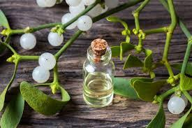

Chest pain, pulse

Congestion, constriction

Nerve pain

Female organs

Depression

**Modalities:**

>abdomen distention wind and leaning backwards

>counter pressure

> Coffee, helps them to sleep

>resting quietly

>walking in the fresh air

<slightest movement

<winter

<cold

< stormy weather

<becoming chilled while hot

<heat

<in bed< lying on left side

<suppression of menses

<mental effort

<tabacco

< noise

**SAI**:

Brain is swaying around the inside of the skull, feeling lightness as if floating on air.

Sensation- can take on anything.

Someone dragging them down from the waist.

Burning coal under right shoulder.

Whole vault of skull was lifted up.

A hand were squeezing the heart, tickling sensation.

**SRP**:

Nausea at the sight of the bottle containing the medicine to be taken.

**Fear**:

Telephones

**Organ Affinities**:

Nervous system, heart, lungs, female organs, muscles, joints

**Symptom table at a glance:** (Murphy, 2021)

| Mind | Apathy  Sadness  Lack of optimism  Irritable, Sad, Morose  Restless, nervous, thoughtless, shakes with impatience.  Unable to carry out intellectual activities.  Thoughts keep turning to past events, for hours on end.  Obsessive persistence of thoughts.  Sensation of strength, optimism, gaiety, desire to undertake anything, full of ideas for the future.  Fear of telephones.  dwells on the past Sad; Despair Sensation of lightness; floating |
| --- | --- |
| Abdomen | Sore waist.  Colitis  Chronic pancreatitis. |
| Back | Lumbago from a chill, wants pressure |
| Chest | Angina pectoris.  Nervous dyspnea (shortness of breath) with feeling of constriction in chest. |
| Ears | Deafness from cold.  Buzzing, stopped up feeling.  Hears heartbeat. |
| Eyes | Blue rings around eyes.  Ocular neuralgia. |
| Face | Constant agitation of facial muscles.  Hot and flushed. |
| Female | Menses early, copious, bright re blood, painful.  Chronic endometriosis.  Post partum haemorrhage  Menopausal complaints  Pain from sacrum into pelvis with tearing, shooting pains from above downwards.  Ovarian pain, esp. left.  Retained placenta. |
| Head | Sudden throbbing in vertex.  Dull, heavy, aching, numbing and congestive, beating or hammering. |
| Heart | Hypertrophy, valvular insufficiency, pulse weak and small.  Low blood pressure  Weight and oppression of heart as if a hand were squeezing it, tickling sensation  Inflammation of arteries  Tightness, heaviness  Irregular heartbeat  Agitation and fibrillation  Pulse accelerated or slow with fear of death  palpitations |
| Kidneys | Bladder paralysed |
| limbs | Chorea-like movements  A glow rises from feet to head, seems to be on fire  General tremor  Dropsy  Sciatica  Drawing, tearing pains  Pains alternate – knee and ankle, shoulder and elbow  Worse in bed  cannot keep legs still  itching all over  burning sensation in feet |
| lungs | Feeling of suffocating when lying on left side  Asthma  Glotteral spasms  Spasmodic cough |
| Male | Violent painful erection  Cramping pain in the prostate |
| mouth | Lips cracked  Dryness of mouth  Mouth suddenly fills with saliva  Teeth chattered |
| nose | Catarrhal congestion  Polyps  Nosebleed |
| rectum | Feeling of constriction  Stools explosive, dry and hard  Splinter like pain  Bleeding hemorrhoids |
| skin | Itching and tingling  Formication along the arms |
| stomach | Cutting pain  Heavy sensation, feeling of a stone in the stomach |
| temperature | General shivering followed by sudden hot flush |
| throat | Burning  Sensation of constriction |
| vertigo | After epileptic attack  Sensation of lightness, as if floating on air |

**Remedy comparison/differentiation: :** (Murphy 2021 (Phatak, 1993), Phatak, Julian 1990)

All of the MM’s I looked in relation to Viscus album agreed that it is one of the foremost anti-arthritic remedies. (Choudary) listing remedies like Aconite, Bryonia and Rhus tox. I will take a closer look at 6 of the remedies commonly found in the Materia Medicas, namely, Aconite, Bryonia, Pulsatilla, Rhododendron, Rhus and Spigelia in relation to the key areas which run through Viscum Album and how they can be differentiated.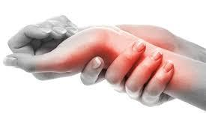

***Rhumatism*:**

Inflammation and pain in joints, muscles or fibrous tissue, especially rheumatoid arthritis. So in the case of all these conditions it is the pain and original causation to be considered.

Viscus Album: Acute and chronic rheumatism. Causation: chill, wetting, fright. Specific to right sided lumbago. Old spinal irritations, clutching pain, Symptoms associated with the uterus, heavy legs.

Aconite: sudden onset, extreme fear, chill, injury, shock, burning, numbness, tingling.

Bryonia: often follows aconite, slow start, less rapid, <movement, irritable, thirsty, joints red, swollen and hot.

Pulsatilla: > warmth, timid, thirstless, symptoms change, shift, needs open air, fears to be alone, rapidly moving pain, joints swollen and red.

Rhododendron: Caused by stormy weather, rough, windy, fear of thunder. Affects fibrous tissue of forearm, lower leg, small joints. Bruised feeling. Rheumatism in hot weather.

Rhus tox: Exposure to wet and cold after being hot and sweaty. <before a storm. Must move, < on first movement, > continued movement. Helpless, dependant, prickling limbs, numbness, itchy, pain on back of thighs.

Spigelia: neuralgia, pain intense in all parts, pain extends, pain presses out. Cause: chill or tobacco. Morose, even suicidal, fear of pointed things, < touch, vertigo. Eye symptoms accompany with heart.

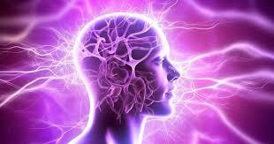

***Epilepsy***:

Visc Alb: Epilepsy and aura, petit mal

Acon: convulsions from fear, apoplexy

Puls: Not mentioned except with absent menses.

Rhod: vertigo, no epilepsy.

Rhus tox: Vertigo, delirium, no epilepsy.

Spig: Vertigo, neuralgia, no epilepsy.

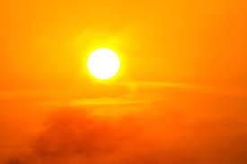

***Heat***:

Visc Alb: < becoming chilled when hot

Acon: Caused by cold.

Bry: < hot weather.

Puls: > cold

Rhod: < cold, > sunshine.

Rhus tox: > heat, < cold.

Spig: < sun (not necessarily heat)

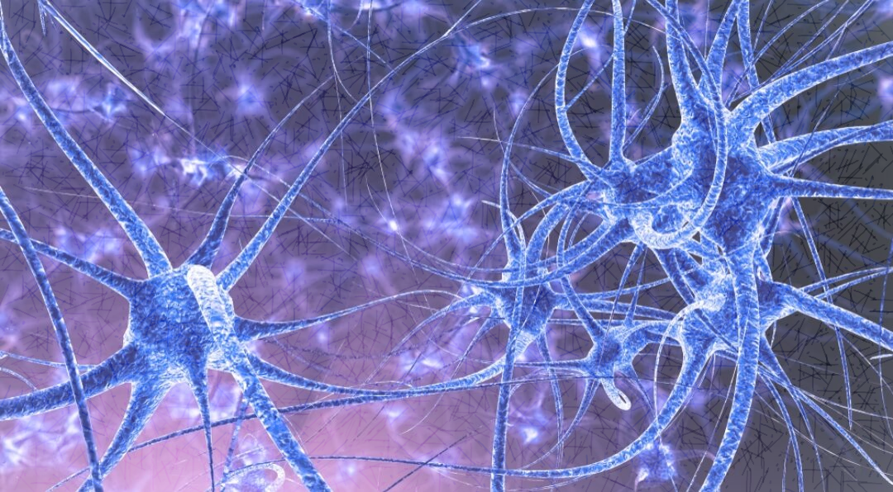

***Nerve pain:***

Visc Alb: Neuralgia, sciatica with otorrhoea, lumbago, red hot pain in heel, sacral pain, detailed pain in lower ;limbs.

Acon: Intense neuralgia, extreme, acute, sticking, tearing pain, wishes to die.

Bry: Pain bursting, stitching - needs pressure.

Puls: Pain burning, stitching, numbing, symptoms moving around, wandering.

Rhod: paralytic pain, pain in limbs, tearing in periosteum of long bones.

Rhus Tox: Pains tearing, shooting, stitching < night.

Spig: Violent pain, neuralgia, hot needles, radiates to other parts.

***Female Organ problems:*** 

Visc Alb: Ovarian pain, faints before menses, metrorrhagia – blood dark, bright, clotted, uterine contraction, stops haemorrhages, endometriosis.

Acon: Fear causing suppression of menses, after pains with fear, dysmenorrhoea, uterine haemorrhages with fear of death, inflamed vagina, copious leucorrhoea.

Bry: Menses supressed, too profuse, nose bleads instead (vicarious), menses with bad smell, dark, heavy loss, lumps in breast, inflamed labia, menses with pain in limbs, burning pain in uterus during pregnancy > still, > pressure, infections after childbirth.

Puls: Amenorrhoea from bathing (getting wet), nervous, anaemia, delayed puberty. Loss scanty, painful. Leucorrhoea thick, creamy. Milk produced by girls before puberty. Weak labour pains, weeps. Haemorrhage with retained placenta. Milk supressed too little or too much.

Rhod: Supressed or premature menses. Fever and headache with menses. Cysts in ovary and vagina.

Rhus Tox: Menses late, too profuse or too light, too long, heavy after getting wet, bleed during pregnancy. Uterine polyps, cancer.

***Mental Comparison:*** 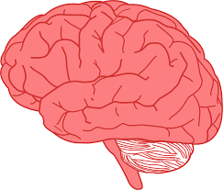

Visc Alb: Incoherent talk, stupor but can be violent, Can lie motionless yet suddenly respond to load noises (hate or fear of the telephone). Trembles – feels as if going to do a bad thing, great depression.

Acon: Rapid action, acute, violent, painful, frantic, fearful, irritable, terror stricken, fears death.

Bry: Very irritable, taciturn, dreads the future, wants to go home.

Puls: Mild, timid, emotional, tearful, whines, craves sympathy, fears being alone.

Rhod: Mentally confused, nervous of thunder and stormy weather, delirium, agitated, staggers around.

Rhus Tox: Sad, fear of poisoning, very restless despondent, confused, desire to be alone.

Spig: Sad, agitated, timid, fear of pointed things, so dejected could kill himself.

**Antidoted by**: Camph., Chi.

**Follows well**: Aco. (rheumatism).

Aditional Remedies to consider are:

Bell., Stram, Plumb (Epilepsy). Calc. (Effects of working in water) Acon (Chill, fright). Secale (Uterine action)., Aco., Bry., Puls., Rho., Rhus, Spi (Rheumatism) (Clarke) or Secale, Convallar, Bry, Puls, Rhodod. **(Boericke pocket)**

**Final comments**

It is fascinating to see that from this humble and familiar plant comes such broad and exciting treatments both in remedy, herbal and extracted forms, with its uses extending to deep pathological diseases, of cancers and tumours right through the nervous and circulatory systems, to vertigo and congestion.

Steeped in mystery and tradition, the mistletoe has so much to offer beyond the firmly established tradition of kissing under the mistletoe! 

**Rubric index**

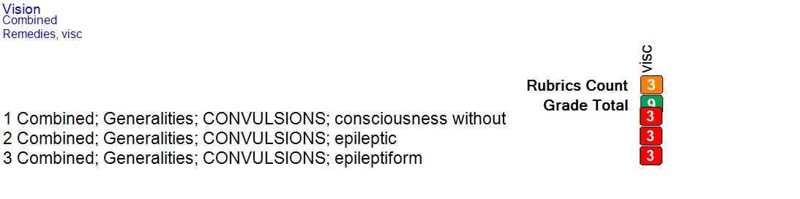

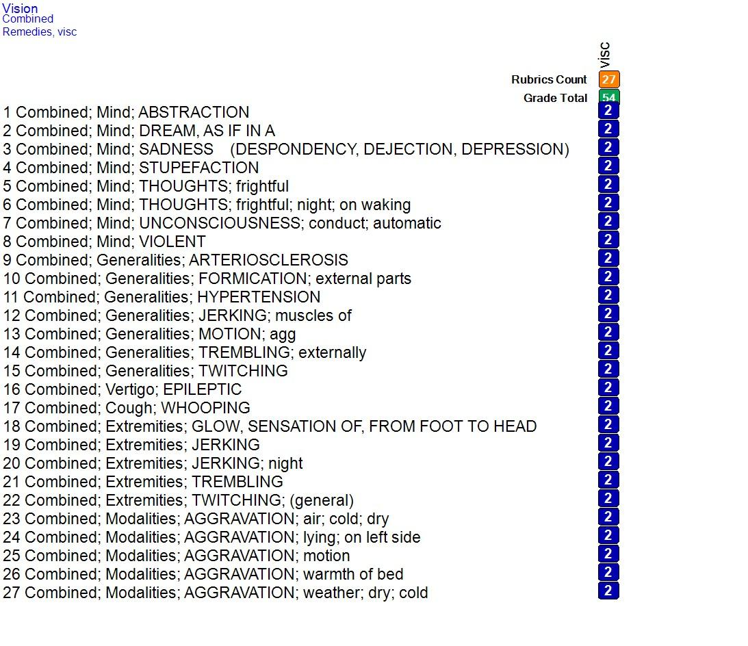

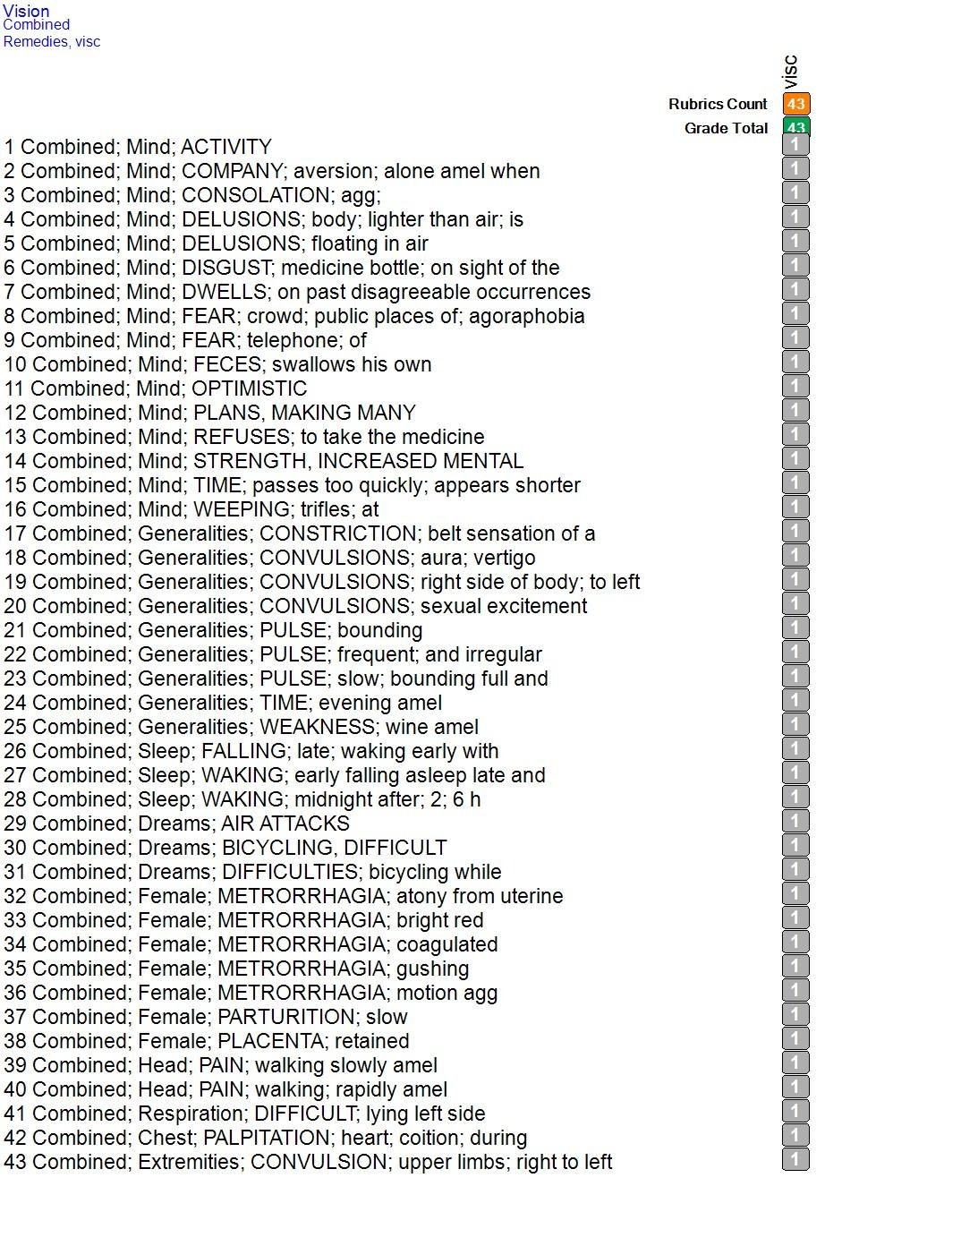

**Synthesis Rubrics**

**Italic and bold symptoms**

MIND - ABSTRACTION OF MIND: (1) *Visc.* + (118)

MIND - DREAM; AS IF IN A: (1) *Visc.* + (111)

MIND - ELATED: (1) *Visc.* + (41)

MIND - SADNESS: (= ... ) (1) *Visc.* + (763)

MIND - STUPEFACTION: (= ... ) (1) *Visc.* + (316)

MIND - THOUGHTS - frightful: (1) *Visc.* + (15)

MIND - THOUGHTS - frightful - night: (1) *Visc.* + (5)

MIND - THOUGHTS - frightful - night - waking; on: (1) *Visc.* + (2)

MIND - UNCONSCIOUSNESS - conduct, automatic: (1) *Visc.* + (29)

MIND - VIOLENT: (1) *Visc.* + (133)

VERTIGO - EPILEPTIC: (1) *Visc.* + (22)

HEARING - LOST - rheumatic: (1) *Visc.*

RESPIRATION - ASTHMATIC - accompanied by - gout: (1) *Visc.* + (2)

RESPIRATION - ASTHMATIC - accompanied by - rheumatic pains: (1) *Visc.* + (4)

RESPIRATION - WHEEZING: (1) *Visc.* + (160)

COUGH - WHOOPING: (= ... ) (1) *Visc.* + (178)

EXTREMITIES - GLOW FROM FOOT TO HEAD; SENSATION OF: (1) *Visc.*

EXTREMITIES - JERKING: (1) *Visc.* + (180)

EXTREMITIES - JERKING night: (1) *Visc.* + (11)

EXTREMITIES - PAIN Ankles: (1) *Visc.* + (254)

EXTREMITIES - PAIN - Elbows: (1) *Visc.* + (268)

EXTREMITIES - PAIN - Joints - gouty: (1) *Visc.* + (207)

EXTREMITIES - TREMBLING: (1) *Visc.* + (349)

EXTREMITIES - TWITCHING: (1) *Visc.* + (274)

SKIN - FORMICATION: (1) *Visc.* + (167)

GENERALS - ARTERIOSCLEROSIS: (1) *Visc.* + (78)

GENERALS - CONVULSIONS - consciousness - without: (1) **VISC.** + (75)

GENERALS - CONVULSIONS - epileptic: (1) **VISC.** + (262)

GENERALS - CONVULSIONS - epileptic - during epileptic convulsions; complaints - vertigo: (1) *Visc.* + (26)

GENERALS - CONVULSIONS - epileptiform: (1) **VISC.** + (133)

GENERALS - FORMICATION: (1) *Visc.* + (220)

GENERALS - FORMICATION - External parts: (1) *Visc.* + (210)

GENERALS - HYPERTENSION: (1) *Visc.* + (156)

GENERALS - JERKING: (1) *Visc.* + (191)

GENERALS - JERKING - Muscles, of: (1) *Visc.* + (153)

GENERALS - MOTION - agg.: (1) *Visc.* + (317)

GENERALS - PAIN: (1) *Visc.* + (764)

GENERALS - PAIN - tearing pain: (1) *Visc.* + (129)

GENERALS - TREMBLING - Externally: (= ... ) (1) *Visc.* + (396)

GENERALS TWITCHING: (1) *Visc.* + (271)

**Single remedy rubrics (italic/bold are highlighted)**

MIND - DELUSIONS - do - dreadful while trembling; he were going to do something: (1) visc.

MIND - DELUSIONS - figures - seeing figures - dozing; when: (1) visc.

MIND - DELUSIONS - floating - air, in - upper part of body: (1) visc.

MIND - DELUSIONS - sleeping - sound sleep; he were in a: (1) visc.

MIND - DISGUST - medicine bottle, on sight of the: (1) visc.

MIND - IRRITABILITY - pain, during - Chest; in: (1) visc.

VERTIGO - FALL, TENDENCY TO - forenoon - 10 h: (1) visc.

VERTIGO - MOTION - eyes; of - sideways agg.: (1) visc.

HEAD - FULLNESS - accompanied by - Extremities; coldness of: (1) visc.

HEAD - MENTAL EXERTION - agg. - Occiput: (1) visc.

HEAD - PAIN - Occiput - Bones - left: (1) visc.

HEAD - PAIN - Occiput - Bones - left - shooting pain: (1) visc.

HEAD - PAIN - Temples - metrorrhagia; during: (1) visc.

HEAD - PAIN - Temples - metrorrhagia; during - stitching pain: (1) visc.

HEAD - PULSATING - Vertex - sudden: (1) visc.

EYE - CLOSING THE EYES - desire to - morning - waking; on: (1) visc.

EYE - LACHRYMATION - rising agg.: (1) visc.

EYE - LACHRYMATION - tiredness; from: (1) visc.

EYE - LACHRYMATION weakness; from: (1) visc.

EAR - NOISES IN - crackling left: (1) visc.

EAR - NOISES IN - wind, sound of - tree; in: (1) visc.

EAR - PAIN - right - twinging - followed by - left: (1) visc.

HEARING - LOST - rheumatic: (1) *Visc.*

NOSE - CATARRH - watery: (1) visc.

NOSE - DRYNESS - Posterior nares - extending to - Larynx: (1) visc.

MOUTH - TASTE - tannic: (1) visc.

STOMACH - HEARTBURN - night - midnight - after - 1-3 h - waking; on: (1) visc.

STOMACH - PAIN - night - midnight - after - 1-3 h - waking; on: (1) visc.

STOMACH - PAIN - night - midnight - after - 1-3 h - waking; on - stitching pain: (1) visc.

ABDOMEN - DISTENSION - painful - bending backward - amel.: (1) visc.

ABDOMEN - DISTENSION - painful - flatus; passing - amel.: (1) visc.

ABDOMEN - DRAGGING - Waist; down: (1) visc.

ABDOMEN - PAIN - Inguinal region - extending to - Spermatic cord; along - twinging: (1) visc.

BLADDER - PARALYSIS - sensation of - urination agg.; during: (1) visc.

BLADDER - URINATION - fever; during - night: (1) visc.

PROSTATE GLAND - PAIN - cramping: (1) visc.

FEMALE GENITALIA/SEX - PAIN - Ovaries - left - lying - side; on - left - agg. - stitching pain: (1) visc.

FEMALE GENITALIA/SEX - PAIN - Ovaries - morning - bed agg.; in: (1) visc.

FEMALE GENITALIA/SEX - PAIN - Ovaries - morning - bed agg.; in - sharp: (1) visc.

CHEST - COLDNESS - External chest - left side: (1) visc.

CHEST - CONSTRICTION - Lungs - Upper part - left: (1) visc.

CHEST - HEART; COMPLAINTS OF THE - Valves - accompanied by - sexual disturbances or diseases: (1) visc.

CHEST - PAIN - Mammae - Upper part - left: (1) visc.

CHEST - PAIN - Mammae - Upper part - left - stitching pain: (1) visc.

CHEST - PAIN - Sternum - lying on left side agg.: (1) visc.

CHEST - TICKLING IN - Heart: (1) visc.

BACK - PAIN - Dorsal region - Shoulders - Between - aching: (= ... ) (1) visc.

BACK - PAIN - Spine - accompanied by - Uterus; complaints of the: (1) visc.

EXTREMITIES - CONVULSION - Upper limbs - right - extending to - left: (1) visc.

EXTREMITIES - FORMICATION - Hands - spider; as if from a: (1) visc.

EXTREMITIES - GLOW FROM FOOT TO HEAD; SENSATION OF: (1) *Visc.*

EXTREMITIES - INSECURE: (1) visc.

EXTREMITIES - PAIN - Feet - right - aching: (= ... ) (1) visc.

EXTREMITIES - PAIN - Knees - Above - right - stitching pain: (1) visc.

EXTREMITIES - PAIN - Legs - sleep - preventing sleep: (1) visc.

EXTREMITIES - PAIN - Legs - Calves - motion - amel. - burning: (1) visc.

EXTREMITIES - PAIN - Lower limbs - Sciatic nerve - discharge from ear, with: (1) visc.

EXTREMITIES - PAIN - Thighs - right - stitching pain: (1) visc.

EXTREMITIES - SHORT, SENSATION AS IF - Thighs - Muscles - Flexor muscles: (1) visc.

SLEEP - SLEEPLESSNESS - pain; from - Legs - right: (1) visc.

CHILL - BEGINNING IN - Chest - left side: (1) visc.

PERSPIRATION - WARM - moist; and: (1) visc.

SKIN - HEAT - fever; without - moist; and: (1) visc.

SKIN - MOISTURE - warm; and: (1) visc.

GENERALS - CIRCULATION; COMPLAINTS OF THE BLOOD - coition - agg.: (1) visc.

GENERALS - CONSTRICTION - External - belt: (1) visc.

GENERALS - CONVULSIONS - right side of body - left; to: (1) visc.

GENERALS - DRUNK; AS IF: (1) visc.

GENERALS - HEAT - sensation of - urination; during - night: (1) visc.

GENERALS - HYPERTENSION - accompanied by - urine; albuminous: (1) visc.

GENERALS - MOTION - stumbling: (1) visc.

GENERALS - PULSE - slow - bounding, full and: (1) visc.

**Synthesis – Mind Rubrics**

MIND - ABSTRACTION OF MIND: (1) *Visc.* + (118)

MIND - ACTIVITY - desires activity: (1) visc. + (162)

MIND - AILMENTS FROM - fright: (1) visc. + (85)

MIND - ANSWERING - stupor returns quickly after answering: (1) visc. + (16)

MIND - ANXIETY: (1) visc. + (690)

MIND - CHEERFUL: (1) visc. + (375)

MIND - COMPANY - aversion to: (1) visc. + (296)

MIND - COMPANY - aversion to - alone amel.; when: (1) visc. + (58)

MIND - CONFIDENCE - want of self-confidence: (1) visc. + (204)

MIND - CONFUSION OF MIND: (1) visc. + (573)

MIND - CONFUSION OF MIND - intoxicated - as if: (1) visc. + (59)

MIND - CONSOLATION - agg.: (1) visc. + (56)

MIND - COWARDICE: (1) visc. + (102)

MIND - DELUSIONS: (= ... ) (1) visc. + (669)

MIND - DELUSIONS - body - lighter than air; body is: (1) visc. + (16)

MIND - DELUSIONS - brain - tightening: (1) visc. + (2)

MIND - DELUSIONS - do - dreadful while trembling; he were going to do something: (1) visc.

MIND - DELUSIONS - falling - he is: (1) visc. + (45)

MIND - DELUSIONS - fancy, illusions of: (1) visc. + (131)

MIND - DELUSIONS - figures - seeing figures: (1) visc. + (56)

MIND - DELUSIONS - figures - seeing figures - dozing; when: (1) visc.

MIND - DELUSIONS - floating: (1) visc. + (96)

MIND - DELUSIONS - floating - air, in: (1) visc. + (91)

MIND - DELUSIONS - floating - air, in - upper part of body: (1) visc.

MIND - DELUSIONS - ground - gave way beneath his feet: (1) visc. + (7)

MIND - DELUSIONS - mind - out of his mind; he would go: (1) visc. + (11)

MIND - DELUSIONS - sleeping - sound sleep; he were in a: (1) visc.

MIND - DELUSIONS - specters, ghosts, spirits: (1) visc. + (96)

MIND - DELUSIONS - specters, ghosts, spirits - seeing: (1) visc. + (61)

MIND - DISCOURAGED: (1) visc. + (188)

MIND - DISGUST: (1) visc. + (71)

MIND - DISGUST - medicine bottle, on sight of the: (1) visc.

MIND - DREAM; AS IF IN A: (1) *Visc.* + (111)

MIND - DWELLS - past disagreeable occurrences, on: (1) visc. + (83)

MIND - ELATED: (1) *Visc.* + (41)

MIND - ELATED - alternating with - sadness: (1) visc. + (8)

MIND - EXCITEMENT: (= ... ) (1) visc. + (490)

MIND - EXCITEMENT - nervous: (1) visc. + (173)

MIND - EXHILARATION: (1) visc. + (162)

MIND - FEAR: (= ... ) (1) visc. + (683)

MIND - FEAR - buildings - of buildings: (1) visc. + (4)

MIND - FEAR - crowd, in a: (1) visc. + (131)

MIND - FEAR - death, of: (1) visc. + (256)

MIND - FEAR - open spaces; fear of: (= ... ) (1) visc. + (41)

MIND - FEAR - telephone, of: (1) visc. + (1)

MIND - FECES - swallows feces - own; his: (1) visc. + (7)

MIND - FORGETFUL: (1) visc. + (345)

MIND - HURRY: (= ... ) (1) visc. + (242)

MIND - HYSTERIA: (1) visc. + (274)

MIND - INDIFFERENCE: (1) visc. + (445)

MIND - IRRITABILITY: (1) visc. + (646)

MIND - IRRITABILITY - pain, during: (1) visc. + (30)

MIND - IRRITABILITY - pain, during - Chest; in: (1) visc.

MIND - LAZINESS: (1) visc. + (381)

MIND - MEMORY - loss of memory: (1) visc. + (108)

MIND - MEMORY - weakness of memory: (1) visc. + (404)

MIND - MENTAL EXERTION - agg.: (1) visc. + (223)

MIND - MENTAL EXERTION - agg. - impossible: (1) visc. + (133)

MIND - MENTAL POWER - increased: (1) visc. + (45)

MIND - MISTAKES; MAKING: (1) visc. + (263)

MIND - MISTAKES; MAKING - speaking, in: (1) visc. + (164)

MIND - MISTAKES; MAKING - writing, in: (1) visc. + (147)

MIND - MOROSE: (= ... ) (1) visc. + (378)

MIND - OPTIMISTIC: (1) visc. + (36)

MIND - PLANS - making many plans: (1) visc. + (35)

MIND - PROSTRATION OF MIND: (= ... ) (1) visc. + (361)

MIND - REFUSING - medicine; to take the: (1) visc. + (12)

MIND - RESTLESSNESS: (1) visc. + (699)

MIND - RESTLESSNESS - night: (1) visc. + (280)

MIND - SADNESS: (= ... ) (1) *Visc.* + (763)

MIND - SENSITIVE: (= ... ) (1) visc. + (438)

MIND - SENSITIVE - noise, to: (1) visc. + (255)

MIND - SPEECH - incoherent: (1) visc. + (86)

MIND - STUPEFACTION: (= ... ) (1) *Visc.* + (316)

MIND - STUPOR: (1) visc. + (169)

MIND - TACITURN: (1) visc. + (315)

MIND - THOUGHTS - frightful: (1) *Visc.* + (15)

MIND - THOUGHTS - frightful - night: (1) *Visc.* + (5)

MIND - THOUGHTS - frightful - night - waking; on: (1) *Visc.* + (2)

MIND - THOUGHTS - persistent: (1) visc. + (150)

MIND - TIME - quickly, appears shorter; passes too: (1) visc. + (43)

MIND - UNCONSCIOUSNESS: (= ... ) (1) visc. + (356)

MIND - UNCONSCIOUSNESS - conduct, automatic: (1) *Visc.* + (29)

MIND - UNCONSCIOUSNESS - frequent spells of unconsciousness: (= ... ) (1) visc. + (21)

MIND - VIOLENT: (1) *Visc.* + (133)

MIND - WEEPING: (= ... ) (1) visc. + (454)

MIND - WEEPING - trifles, at: (1) visc. + (54)

# References

Anshutz, E. (2002). *New, old and forgotten remedies.* Jain.

Briggs, J. (2020). *A Little book about mistletoe.* Gloustershire: Potamogeton Press.

Gerstel, D. V. ( 1886). Hom. Allgemeine Zeitung.

H.Clarke, J. (1902). *Dictionary of practical Materia medica.*

Hering, C. (1993). *Condensed Materia Medica.* Delhi: B. Jain Publishers Pvt. :td.

Ivatts, D. (1876). *Hom. World*.

Julian, O. (1990). *Materia Medica of new Homeopathic Remedies.* Bucks, UK.: Beaconsfield publishers LTD.

Kent, J. T. (1990). *Repertory of the Homeopathic Materia Medica.* Kent: Homeopathic book service.

M.D., J. W. (1994). *Seven-Hundred redline symptoms.* Delhi: B. Jain Publishers (P) Ltd.

miccant vision software. (2024).

Mont, K. (2010, Winter). Mistletoe: Magic, mythology and medicine. *Homeopathy in practice* , pp. 14-19.

Mulder, F. A. (2009, Spring). Mistletoe. *The Homeopath*, pp. 119-121.

Murphy, R. (2020). *Nature's Materia Medica.* Virginia USA: Lotus Health Institute.

Murphy, R. (2021). *MetaRepertory.* Virginia USA: Lotus Health Institute.

Phatak. (1993). *Materia Medica of homeopathic medicines.* New Delhi: Jain.

Winters, S. J. (2023). *Mistletoe and the emerging future of integrative oncology.* NY: Portal books.

www.hopkinsmedicine.org/news/newsroom/news-releases/2023/02/us-study-of-intravenous-mistletoe-extract-to-treat-advanced-cancer. (2023). US study of intravenous mistletoe extracts to treat advanced cancer. *hopkins medicine*.

# Bibliography

Anshutz, E. (2002). *New, old and forgotten remedies.* Jain.

Briggs, J. (2020). *A Little book about mistletoe.* Gloustershire: Potamogeton Press.

Gerstel, D. V. ( 1886). Hom. Allgemeine Zeitung.

H.Clarke, J. (1902). *Dictionary of practical Materia medica.*

Hering, C. (1993). *Condensed Materia Medica.* Delhi: B. Jain Publishers Pvt. :td.

Ivatts, D. (1876). *Hom. World*.

Julian, O. (1990). *Materia Medica of new Homeopathic Remedies.* Bucks, UK.: Beaconsfield publishers LTD.

Kent, J. T. (1990). *Repertory of the Homeopathic Materia Medica.* Kent: Homeopathic book service.

M.D., J. W. (1994). *Seven-Hundred redline symptoms.* Delhi: B. Jain Publishers (P) Ltd.

miccant vision software. (2024).

Mont, K. (2010, Winter). Mistletoe: Magic, mythology and medicine. *Homeopathy in practice* , pp. 14-19.

Mulder, F. A. (2009, Spring). Mistletoe. *The Homeopath*, pp. 119-121.

Murphy, R. (2020). *Nature's Materia Medica.* Virginia USA: Lotus Health Institute.

Murphy, R. (2021). *MetaRepertory.* Virginia USA: Lotus Health Institute.

Phatak. (1993). *Materia Medica of homeopathic medicines.* New Delhi: Jain.

Winters, S. J. (2023). *Mistletoe and the emerging future of integrative oncology.* NY: Portal books.

www.hopkinsmedicine.org/news/newsroom/news-releases/2023/02/us-study-of-intravenous-mistletoe-extract-to-treat-advanced-cancer. (2023). US study of intravenous mistletoe extracts to treat advanced cancer. *hopkins medicine*.

**Appendix**

**All general rubrics**

VERTIGO - VERTIGO: (1) visc. + (617)

VERTIGO - CONVULSIONS; BEFORE EPILEPTIC: (1) visc. + (10)

VERTIGO - EPILEPTIC: (1) *Visc.* + (22)

VERTIGO - FALL, TENDENCY TO: (1) visc. + (202)

VERTIGO - FALL, TENDENCY TO - forenoon - 10 h: (1) visc.

VERTIGO - FALL, TENDENCY TO - backward: (1) visc. + (47)

VERTIGO - MOTION - agg.: (1) visc. + (99)

VERTIGO - MOTION - eyes; of - sideways agg.: (1) visc.

VERTIGO - RISING - agg.: (1) visc. + (126)

VERTIGO - SUDDEN: (1) visc. + (43)

HEAD - CONGESTION: (1) visc. + (300)

HEAD - CONGESTION - painful: (1) visc. + (20)

HEAD - CONSTRICTION: (1) visc. + (333)

HEAD - CONSTRICTION - Brain: (1) visc. + (13)

HEAD - CONSTRICTION - Brain - compressed; as if whole brain was: (1) visc. + (9)

HEAD - EMPTY, HOLLOW SENSATION: (1) visc. + (115)

HEAD - FULLNESS: (1) visc. + (244)

HEAD - FULLNESS - accompanied by - Extremities; coldness of: (1) visc.

HEAD - FULLNESS - burst, as if would: (1) visc. + (14)

HEAD - LOOSENESS OF BRAIN, SENSATION OF: (1) visc. + (92)

HEAD - MENTAL EXERTION - agg.: (1) visc. + (54)

HEAD - MENTAL EXERTION - agg. - Occiput: (1) visc.

HEAD - NUMBNESS; SENSATION OF: (1) visc. + (129)

HEAD - PAIN: (= ... ) (1) visc. + (766)

HEAD - PAIN - accompanied by - nausea: (1) visc. + (211)

HEAD - PAIN - air; in open - amel.: (1) visc. + (170)

HEAD - PAIN - bending - head - forward - agg.: (1) visc. + (22)

HEAD - PAIN - cold - applications - amel.: (1) visc. + (95)

HEAD - PAIN - cutting pain: (1) visc. + (105)

HEAD - PAIN - dull pain: (1) visc. + (295)

HEAD - PAIN - hammering pain: (1) visc. + (68)

HEAD - PAIN - hemorrhage - during: (1) visc. + (1)

HEAD - PAIN - hemorrhage - during - dull pain: (1) visc. + (1)

HEAD - PAIN - lying - agg.: (1) visc. + (99)

HEAD - PAIN - lying - amel.: (1) visc. + (95)

HEAD - PAIN - mental exertion - agg.: (1) visc. + (152)

HEAD - PAIN - perspiration - with: (1) visc. + (35)

HEAD - PAIN - pressing pain: (1) visc. + (304)

HEAD - PAIN - pressure - amel.: (1) visc. + (140)

HEAD - PAIN - pulsating pain: (1) visc. + (202)

HEAD - PAIN - sharp: (1) visc. + (10)

HEAD - PAIN - smoking - agg.: (1) visc. + (37)

HEAD - PAIN - walking - air; in open - amel.: (1) visc. + (66)

HEAD - PAIN - walking - slowly - amel.: (1) visc. + (10)

HEAD - PAIN - warmth - agg.: (1) visc. + (23)

HEAD - PAIN - Forehead: (1) visc. + (554)

HEAD - PAIN - Forehead - Eyes - Above - left: (1) visc. + (147)

HEAD - PAIN - Forehead - Eyes - Above - left - stitching pain: (1) visc. + (17)

HEAD - PAIN - Occiput - Bones - left: (1) visc.

HEAD - PAIN - Occiput - Bones - left - shooting pain: (1) visc.

HEAD - PAIN - Temples: (1) visc. + (456)

HEAD - PAIN - Temples - metrorrhagia; during: (1) visc.

HEAD - PAIN - Temples - metrorrhagia; during - stitching pain: (1) visc.

HEAD - PAIN - Vertex: (1) visc. + (375)

HEAD - PAIN - Vertex - top would fly off; as if: (1) visc. + (20)

HEAD - PERSPIRATION OF SCALP - Forehead: (1) visc. + (158)

HEAD - PERSPIRATION OF SCALP - Forehead - cold: (1) visc. + (77)

HEAD - PULSATING: (1) visc. + (324)

HEAD - PULSATING - Vertex: (1) visc. + (77)

HEAD - PULSATING - Vertex - sudden: (1) visc.

EYE - CLOSING THE EYES - desire to: (1) visc. + (42)

EYE - CLOSING THE EYES - desire to - morning - waking; on: (1) visc.

EYE - DISCOLORATION - red: (1) visc. + (306)

EYE - HEAVINESS - Lids: (1) visc. + (162)

EYE - INJECTED: (1) visc. + (97)

EYE - INJECTED - Conjunctiva: (1) visc. + (61)

EYE - INJECTED - Conjunctiva - dark vessels; full of: (1) visc. + (61)

EYE - LACHRYMATION: (1) visc. + (347)

EYE - LACHRYMATION - rising agg.: (1) visc.

EYE - LACHRYMATION - tiredness; from: (1) visc.

EYE - LACHRYMATION - weakness; from: (1) visc.

EYE - OPENING THE LIDS - difficult: (1) visc. + (80)

EYE - PHOTOPHOBIA: (1) visc. + (269)

EYE - PUPILS - contracted: (= ... ) (1) visc. + (152)

EYE - PUPILS - dilated: (= ... ) (1) visc. + (226)

EYE - PUPILS - insensible to light: (1) visc. + (80)

EYE - STARING: (1) visc. + (153)

EYE - SUNKEN: (1) visc. + (138)

VISION - ACCOMMODATION - diminished: (1) visc. + (6)

VISION - ACUTE: (1) visc. + (68)

VISION - FOGGY: (1) visc. + (208)

VISION - ILLUSIONS: (1) visc. + (91)

VISION - ILLUSIONS - colorful: (1) visc. + (1)

EAR - CATARRH - Eustachian tubes: (1) visc. + (78)

EAR - COLD; TAKING A - after: (1) visc. + (17)

EAR - DISCHARGES: (1) visc. + (184)

EAR - NOISES IN: (1) visc. + (498)

EAR - NOISES IN - crackling: (1) visc. + (47)

EAR - NOISES IN - crackling - left: (1) visc.

EAR - NOISES IN - singing: (1) visc. + (104)

EAR - NOISES IN - singing - right: (1) visc. + (10)

EAR - NOISES IN - wind, sound of: (1) visc. + (30)

EAR - NOISES IN - wind, sound of - tree; in: (1) visc.

EAR - PAIN: (= ... ) (1) visc. + (432)

EAR - PAIN - right - twinging - followed by - left: (1) visc.

EAR - PULSATION: (1) visc. + (114)

HEARING - IMPAIRED: (= ... ) (1) visc. + (313)

HEARING - IMPAIRED - left: (1) visc. + (22)

HEARING - IMPAIRED - accompanied by - gout: (1) visc. + (6)

HEARING - IMPAIRED - accompanied by - rheumatism: (1) visc. + (6)

HEARING - IMPAIRED - cold; exposure to: (1) visc. + (2)

HEARING - IMPAIRED - weather - cold - wet - agg.: (1) visc. + (7)

HEARING - LOST: (1) visc. + (193)

HEARING - LOST - left: (1) visc. + (4)

HEARING - LOST - rheumatic: (1) *Visc.*

NOSE - CATARRH: (1) visc. + (291)

NOSE - CATARRH - purulent: (1) visc. + (1)

NOSE - CATARRH - watery: (1) visc.

NOSE - DRYNESS - Posterior nares: (1) visc. + (48)

NOSE - DRYNESS - Posterior nares - extending to - Larynx: (1) visc.

NOSE - EPISTAXIS: (1) visc. + (364)

NOSE - POLYPUS: (1) visc. + (69)

FACE - CRACKED - Lips: (1) visc. + (169)

FACE - DISCOLORATION - bluish: (1) visc. + (220)

FACE - DISCOLORATION - bluish - Eyes - Around; circles: (1) visc. + (131)

FACE - DISCOLORATION - pale: (1) visc. + (345)

FACE - DISCOLORATION - pale - heat; during: (1) visc. + (25)

FACE - DISCOLORATION - pale - Lips: (1) visc. + (46)

FACE - DISCOLORATION - red: (1) visc. + (450)

FACE - DISCOLORATION - red - spots: (1) visc. + (83)

FACE - HEAT: (1) visc. + (372)

FACE - HEAT - flushes: (1) visc. + (138)

FACE - ITCHING: (1) visc. + (183)

FACE - ITCHING - spot: (1) visc. + (7)

FACE - PAIN: (= ... ) (1) visc. + (339)

FACE - PAIN - cutting pain: (1) visc. + (33)

FACE - PAIN - Eyes - Below - right: (1) visc. + (3)

FACE - TWITCHING: (1) visc. + (157)

MOUTH - BLEEDING: (1) visc. + (237)

MOUTH - BLEEDING - Gums: (= ... ) (1) visc. + (195)

MOUTH - DISCOLORATION - yellow: (1) visc. + (5)

MOUTH - DISCOLORATION - yellow - patches: (1) visc. + (1)

MOUTH - DRYNESS: (1) visc. + (434)

MOUTH - DRYNESS - Tongue: (1) visc. + (213)

MOUTH - PAIN - Tongue: (1) visc. + (297)

MOUTH - PAIN - Tongue - sore: (1) visc. + (111)

MOUTH - SALIVATION: (1) visc. + (405)

MOUTH - SALIVATION - sudden attacks: (1) visc. + (4)

MOUTH - SPEECH - wanting: (1) visc. + (91)

MOUTH - SPEECH - wanting - paralysis of organs, from: (1) visc. + (10)

MOUTH - TASTE - altered - cigarette; of his (her) usual: (1) visc. + (1)

MOUTH - TASTE - bad: (1) visc. + (183)

MOUTH - TASTE - bad - morning: (1) visc. + (48)

MOUTH - TASTE - bad - morning - waking; on: (1) visc. + (15)

MOUTH - TASTE - pappy: (1) visc. + (116)

MOUTH - TASTE - tannic: (1) visc.

TEETH - CHATTERING: (1) visc. + (56)

THROAT - CATARRH: (1) visc. + (72)

THROAT - CHOKING: (1) visc. + (249)

THROAT - CONSTRICTION: (1) visc. + (128)

THROAT - DRYNESS: (1) visc. + (400)

THROAT - OBSTRUCTION: (1) visc. + (22)

THROAT - PAIN: (1) visc. + (538)

THROAT - PAIN - burning: (1) visc. + (286)

THROAT - PAIN - sore: (= ... ) (1) visc. + (319)

THROAT - PAIN - warm - drinks - amel.: (1) visc. + (41)

THROAT - PULSATING: (1) visc. + (28)

THROAT - SWALLOWING - difficult: (1) visc. + (286)

THROAT - SWALLOWING - impossible: (1) visc. + (106)

THROAT - SWALLOWING - impossible - choking, from: (1) visc. + (5)

THROAT - SWALLOWING - impossible - paralysis; from: (1) visc. + (26)

EXTERNAL THROAT - TORTICOLLIS: (1) visc. + (81)

STOMACH - APPETITE - increased: (= ... ) (1) visc. + (398)

STOMACH - APPETITE - increased - forenoon: (1) visc. + (30)

STOMACH - APPETITE - increased - forenoon - 11 h: (1) visc. + (13)

STOMACH - APPETITE - insatiable: (1) visc. + (60)

STOMACH - APPETITE - ravenous: (= ... ) (1) visc. + (276)

STOMACH - APPETITE - ravenous - night: (1) visc. + (21)

STOMACH - EMPTINESS: (= ... ) (1) visc. + (302)

STOMACH - EMPTINESS - forenoon: (1) visc. + (26)

STOMACH - EMPTINESS - forenoon - 11 h: (1) visc. + (18)

STOMACH - ERUCTATIONS: (1) visc. + (463)

STOMACH - HEARTBURN: (1) visc. + (277)

STOMACH - HEARTBURN - night: (1) visc. + (20)

STOMACH - HEARTBURN - night - midnight - after - 1-3 h - waking; on: (1) visc.

STOMACH - HEAVINESS: (= ... ) (1) visc. + (208)

STOMACH - INACTIVITY: (1) visc. + (9)

STOMACH - NAUSEA: (1) visc. + (716)

STOMACH - NAUSEA - breakfast - before - agg.: (1) visc. + (23)

STOMACH - NAUSEA - dinner - before: (1) visc. + (4)

STOMACH - NAUSEA - vomiting - amel.: (1) visc. + (4)

STOMACH - PAIN: (= ... ) (1) visc. + (516)

STOMACH - PAIN - night - midnight - after - 1-3 h - waking; on: (1) visc.

STOMACH - PAIN - night - midnight - after - 1-3 h - waking; on - stitching pain: (1) visc.

STOMACH - PAIN - burning: (1) visc. + (277)

STOMACH - PAIN - eating - after - amel.: (1) visc. + (56)

STOMACH - PAIN - eating - after - amel. - cutting pain: (1) visc. + (1)

STOMACH - PAIN - eating - amel.: (1) visc. + (34)

STOMACH - PAIN - eating - amel. - burning: (1) visc. + (6)

STOMACH - PAIN - pressing pain: (1) visc. + (271)

STOMACH - STONE; SENSATION OF A: (1) visc. + (109)

ABDOMEN - DISTENSION: (1) visc. + (406)

ABDOMEN - DISTENSION - painful: (1) visc. + (72)

ABDOMEN - DISTENSION - painful - bending backward - amel.: (1) visc.

ABDOMEN - DISTENSION - painful - flatus; passing - amel.: (1) visc.

ABDOMEN - DISTENSION - sensation of: (1) visc. + (35)

ABDOMEN - DRAGGING: (1) visc. + (2)

ABDOMEN - DRAGGING - Waist; down: (1) visc.

ABDOMEN - LIVER AND REGION OF LIVER; COMPLAINTS OF: (1) visc. + (234)

ABDOMEN - PAIN: (1) visc. + (544)

ABDOMEN - PAIN - burning: (1) visc. + (160)

ABDOMEN - PAIN - dragging, bearing down: (1) visc. + (109)

ABDOMEN - PAIN - menses would appear; as if: (1) visc. + (62)

ABDOMEN - PAIN - Hypochondria: (1) visc. + (252)

ABDOMEN - PAIN - Hypochondria - sore: (1) visc. + (72)

ABDOMEN - PAIN - Inguinal region - left: (1) visc. + (70)

ABDOMEN - PAIN - Inguinal region - left - burning: (1) visc. + (2)

ABDOMEN - PAIN - Inguinal region - extending to - Spermatic cord; along: (1) visc. + (2)

ABDOMEN - PAIN - Inguinal region - extending to - Spermatic cord; along - twinging: (1) visc.

ABDOMEN - PAIN - Spleen: (1) visc. + (193)

ABDOMEN - PARALYSIS OF INTESTINES: (1) visc. + (21)

ABDOMEN - PULSATION: (= ... ) (1) visc. + (129)

ABDOMEN - RUMBLING: (1) visc. + (373)

RECTUM - CONSTIPATION: (= ... ) (1) visc. + (527)

RECTUM - CONSTIPATION - insufficient: (= ... ) (1) visc. + (121)

RECTUM - DIARRHEA: (1) visc. + (685)

RECTUM - DIARRHEA - night: (1) visc. + (135)

RECTUM - DIARRHEA - alternating with - constipation: (1) visc. + (121)

RECTUM - FLATUS: (1) visc. + (368)

RECTUM - FLATUS - offensive: (1) visc. + (193)

RECTUM - HEMORRHAGE FROM ANUS: (1) visc. + (215)

RECTUM - HEMORRHAGE FROM ANUS - red; bright: (1) visc. + (6)

RECTUM - HEMORRHOIDS: (1) visc. + (302)

RECTUM - INACTIVITY OF RECTUM: (1) visc. + (167)

RECTUM - ITCHING: (1) visc. + (281)

RECTUM - ITCHING - stool - after - agg.: (1) visc. + (48)

RECTUM - ITCHING - Anus; around: (1) visc. + (130)

RECTUM - ITCHING - Anus; around - stool - after - agg.: (1) visc. + (13)

RECTUM - PAIN: (1) visc. + (418)

RECTUM - PAIN - evening: (1) visc. + (42)

RECTUM - PAIN - burning: (1) visc. + (216)

RECTUM - PAIN - lying - agg.: (1) visc. + (13)

RECTUM - PAIN - lying - agg. - stitching pain: (1) visc. + (2)

RECTUM - PAIN - stabbing pain: (1) visc. + (1)

RECTUM - PAIN - stitching pain: (1) visc. + (159)

RECTUM - PAIN - tenesmus: (1) visc. + (239)

RECTUM - RECTUM AND ANUS; COMPLAINTS OF - extending to - Thigh: (1) visc. + (1)

STOOL - COPIOUS: (1) visc. + (226)

STOOL - FORCIBLE, SUDDEN, GUSHING: (1) visc. + (129)

STOOL - FORCIBLE, SUDDEN, GUSHING - explosion; like an: (1) visc. + (7)

STOOL - FROTHY: (1) visc. + (78)

STOOL - HARD: (1) visc. + (354)

STOOL - ODOR - offensive: (1) visc. + (256)

STOOL - PASTY, PAPESCENT: (1) visc. + (195)

STOOL - THIN: (1) visc. + (255)

BLADDER - PARALYSIS - sensation of - urination agg.; during: (1) visc.

BLADDER - URINATION - fever; during - night: (1) visc.

BLADDER - URINATION - frequent: (1) visc. + (348)

BLADDER - URINATION - involuntary: (1) visc. + (307)

BLADDER - URINATION - involuntary - cough agg.; during: (1) visc. + (72)

BLADDER - URINATION - retarded, must wait for urine to start: (1) visc. + (120)

BLADDER - URINATION - urging to urinate: (= ... ) (1) visc. + (402)

KIDNEYS - COMPLAINTS OF KIDNEYS: (1) visc. + (108)

KIDNEYS - COMPLAINTS OF KIDNEYS - accompanied by - Lumbar region; complaints of: (1) visc. + (3)

KIDNEYS - PAIN: (= ... ) (1) visc. + (267)

KIDNEYS - PAIN - sore: (= ... ) (1) visc. + (64)

PROSTATE GLAND - PAIN: (1) visc. + (57)

PROSTATE GLAND - PAIN - cramping: (1) visc.

URINE - ALBUMINOUS: (= ... ) (1) visc. + (230)

URINE - CLOUDY: (1) visc. + (231)

URINE - CLOUDY - left standing for a while; when: (1) visc. + (97)

URINE - COLOR - pale: (1) visc. + (215)

URINE - COPIOUS: (= ... ) (1) visc. + (377)

URINE - MILKY: (1) visc. + (68)

URINE - MILKY - left standing for a while; when: (1) visc. + (4)

URINE - SEDIMENT: (1) visc. + (345)

URINE - SEDIMENT - pink: (1) visc. + (14)

MALE GENITALIA/SEX - ERECTIONS: (1) visc. + (367)

MALE GENITALIA/SEX - ERECTIONS - continued: (= ... ) (1) visc. + (114)

MALE GENITALIA/SEX - ERECTIONS - frequent: (1) visc. + (97)

MALE GENITALIA/SEX - INFLAMMATION: (1) visc. + (151)

MALE GENITALIA/SEX - INFLAMMATION - Testes: (= ... ) (1) visc. + (91)

MALE GENITALIA/SEX - PAIN: (1) visc. + (334)

MALE GENITALIA/SEX - PAIN - Spermatic cords: (1) visc. + (132)

MALE GENITALIA/SEX - PAIN - Spermatic cords - extending to - Testes: (1) visc. + (13)

MALE GENITALIA/SEX - PAIN - Spermatic cords - extending to - Upward: (1) visc. + (3)

MALE GENITALIA/SEX - POLLUTIONS: (1) visc. + (288)

MALE GENITALIA/SEX - POLLUTIONS - night: (1) visc. + (72)

MALE GENITALIA/SEX - POLLUTIONS - erections - without: (1) visc. + (97)

MALE GENITALIA/SEX - SEXUAL DESIRE - diminished: (1) visc. + (190)

MALE GENITALIA/SEX - SEXUAL DESIRE - increased: (1) visc. + (297)

FEMALE GENITALIA/SEX - ABORTION: (1) visc. + (157)

FEMALE GENITALIA/SEX - COMPLAINTS OF FEMALE GENITALIA: (1) visc. + (155)

FEMALE GENITALIA/SEX - CONTRACTIONS: (1) visc. + (45)

FEMALE GENITALIA/SEX - CONTRACTIONS - Uterus: (1) visc. + (39)

FEMALE GENITALIA/SEX - DELIVERY - during; complaints: (1) visc. + (81)

FEMALE GENITALIA/SEX - DELIVERY - during; complaints - slow: (1) visc. + (8)

FEMALE GENITALIA/SEX - ENLARGED - Uterus: (1) visc. + (44)

FEMALE GENITALIA/SEX - INFLAMMATION: (1) visc. + (186)

FEMALE GENITALIA/SEX - INFLAMMATION - Ovaries: (= ... ) (1) visc. + (77)

FEMALE GENITALIA/SEX - INFLAMMATION - Uterus: (= ... ) (1) visc. + (123)

FEMALE GENITALIA/SEX - MENOPAUSE: (= ... ) (1) visc. + (118)

FEMALE GENITALIA/SEX - MENSES - bright red: (1) visc. + (112)

FEMALE GENITALIA/SEX - MENSES - copious: (1) visc. + (409)

FEMALE GENITALIA/SEX - MENSES - early; too: (1) visc. + (172)

FEMALE GENITALIA/SEX - MENSES - frequent; too: (1) visc. + (302)

FEMALE GENITALIA/SEX - MENSES - protracted: (1) visc. + (165)

FEMALE GENITALIA/SEX - MENSES - scanty: (1) visc. + (252)

FEMALE GENITALIA/SEX - MENSES - suppressed menses: (1) visc. + (205)

FEMALE GENITALIA/SEX - METRORRHAGIA: (1) visc. + (279)

FEMALE GENITALIA/SEX - METRORRHAGIA - atony, from uterine: (1) visc. + (6)

FEMALE GENITALIA/SEX - METRORRHAGIA - bright red: (1) visc. + (34)

FEMALE GENITALIA/SEX - METRORRHAGIA - coagulated: (= ... ) (1) visc. + (49)

FEMALE GENITALIA/SEX - METRORRHAGIA - dark blood: (1) visc. + (40)

FEMALE GENITALIA/SEX - METRORRHAGIA - dark blood - clots, with: (1) visc. + (17)

FEMALE GENITALIA/SEX - METRORRHAGIA - menses - between: (1) visc. + (63)

FEMALE GENITALIA/SEX - PAIN: (1) visc. + (192)

FEMALE GENITALIA/SEX - PAIN - cramping: (1) visc. + (23)

FEMALE GENITALIA/SEX - PAIN - menses - during - agg.: (1) visc. + (108)

FEMALE GENITALIA/SEX - PAIN - menses - during - agg. - cramping: (1) visc. + (1)

FEMALE GENITALIA/SEX - PAIN - metrorrhagia; during: (1) visc. + (10)

FEMALE GENITALIA/SEX - PAIN - metrorrhagia; during - labor-like: (1) visc. + (10)

FEMALE GENITALIA/SEX - PAIN - Ovaries - left: (1) visc. + (78)

FEMALE GENITALIA/SEX - PAIN - Ovaries - left - lying - side; on - left - agg.: (1) visc. + (2)

FEMALE GENITALIA/SEX - PAIN - Ovaries - left - lying - side; on - left - agg. - stitching pain: (1) visc.

FEMALE GENITALIA/SEX - PAIN - Ovaries - left - stitching pain: (1) visc. + (15)

FEMALE GENITALIA/SEX - PAIN - Ovaries - morning - bed agg.; in: (1) visc.

FEMALE GENITALIA/SEX - PAIN - Ovaries - morning - bed agg.; in - sharp: (1) visc.

FEMALE GENITALIA/SEX - PAIN - Uterus: (1) visc. + (195)

FEMALE GENITALIA/SEX - PAIN - Uterus - lancinating: (1) visc. + (38)

FEMALE GENITALIA/SEX - PLACENTA - retained: (1) visc. + (34)

FEMALE GENITALIA/SEX - SEXUAL DESIRE - diminished: (1) visc. + (149)

FEMALE GENITALIA/SEX - SEXUAL DESIRE - increased: (1) visc. + (241)

FEMALE GENITALIA/SEX - SUBINVOLUTION: (1) visc. + (38)

LARYNX AND TRACHEA - LARYNGISMUS STRIDULUS: (1) visc. + (86)

LARYNX AND TRACHEA - SPASMS - Larynx: (1) visc. + (48)

RESPIRATION - ASTHMATIC: (1) visc. + (385)

RESPIRATION - ASTHMATIC - accompanied by - gout: (1) *Visc.* + (2)

RESPIRATION - ASTHMATIC - accompanied by - rheumatic pains: (1) *Visc.* + (4)

RESPIRATION - ASTHMATIC - bronchial: (1) visc. + (48)

RESPIRATION - DIFFICULT: (1) visc. + (519)

RESPIRATION - DIFFICULT - accompanied by - cough: (1) visc. + (96)

RESPIRATION - DIFFICULT - lying - side; on - left - agg.: (1) visc. + (20)

RESPIRATION - DIFFICULT - lying - side; on - right - agg.: (1) visc. + (4)

RESPIRATION - SLOW: (= ... ) (1) visc. + (126)

RESPIRATION - STERTOROUS: (1) visc. + (103)

RESPIRATION - WHEEZING: (1) *Visc.* + (160)

COUGH - AIR; IN OPEN - amel.: (1) visc. + (37)

COUGH - BARKING: (1) visc. + (71)

COUGH - LYING - agg.: (1) visc. + (131)

COUGH - PAINFUL: (1) visc. + (68)

COUGH - WHOOPING: (= ... ) (1) *Visc.* + (178)

EXPECTORATION - GRAYISH: (1) visc. + (74)

EXPECTORATION - MUCOUS: (1) visc. + (258)

EXPECTORATION - VISCID: (1) visc. + (191)

EXPECTORATION - YELLOW: (1) visc. + (201)

CHEST - CEASES TO BEAT; AS IF HEART - would cease: (1) visc. + (23)

CHEST - COLDNESS: (1) visc. + (99)

CHEST - COLDNESS - External chest: (1) visc. + (7)

CHEST - COLDNESS - External chest - left side: (1) visc.

CHEST - CONSTRICTION: (= ... ) (1) visc. + (348)

CHEST - CONSTRICTION - breathing - deep - agg.: (1) visc. + (29)

CHEST - CONSTRICTION - Heart: (1) visc. + (103)

CHEST - CONSTRICTION - Heart - grasping sensation: (1) visc. + (14)

CHEST - CONSTRICTION - Heart - grasping sensation - iron hand; as if grasped by an: (1) visc. + (6)

CHEST - CONSTRICTION - Lungs: (1) visc. + (6)

CHEST - CONSTRICTION - Lungs - Upper part - left: (1) visc.

CHEST - DISCOLORATION - redness: (1) visc. + (46)

CHEST - DISCOLORATION - redness - spots: (1) visc. + (28)

CHEST - HEART; COMPLAINTS OF THE: (= ... ) (1) visc. + (282)

CHEST - HEART; COMPLAINTS OF THE - accompanied by - respiration - difficult: (1) visc. + (47)

CHEST - HEART; COMPLAINTS OF THE - Valves: (1) visc. + (48)

CHEST - HEART; COMPLAINTS OF THE - Valves - accompanied by - sexual disturbances or diseases: (1) visc.

CHEST - HEARTBEAT violent beat; single: (1) visc. + (4)

CHEST - HEAT sensation of: (1) visc. + (41)

CHEST - HEAT - sensation of - Heart - In: (1) visc. + (2)

CHEST - HYPERTROPHY - Heart; of: (1) visc. + (56)

CHEST - INFLAMMATION: (1) visc. + (372)

CHEST - INFLAMMATION - Bronchial tubes: (= ... ) (1) visc. + (235)

CHEST - LYING - impossible: (1) visc. + (8)

CHEST - LYING - side; on - left - agg.: (1) visc. + (39)

CHEST - MAMMAE; COMPLAINTS OF - Below: (1) visc. + (18)

CHEST - MAMMAE; COMPLAINTS OF - Below - left: (1) visc. + (11)

CHEST - OPPRESSION: (1) visc. + (386)

CHEST - PAIN: (1) visc. + (451)

CHEST - PAIN - breathing - deep - agg.: (1) visc. + (95)

CHEST - PAIN - burning: (1) visc. + (177)

CHEST - PAIN - Heart - extending to - Arm - left: (1) visc. + (15)

CHEST - PAIN - Mammae - Under: (1) visc. + (35)

CHEST - PAIN - Mammae - Under - left: (1) visc. + (37)

CHEST - PAIN - Mammae - Under - left - stitching pain: (1) visc. + (21)

CHEST - PAIN - Mammae - Upper part - left: (1) visc.

CHEST - PAIN - Mammae - Upper part - left - stitching pain: (1) visc.

CHEST - PAIN - Ribs - Lower - left: (1) visc. + (14)

CHEST - PAIN - Ribs - Lower - left - stitching pain: (1) visc. + (10)

CHEST - PAIN - Sternum - lying on left side agg.: (1) visc.

CHEST - PALPITATION OF HEART: (1) visc. + (515)

CHEST - PALPITATION OF HEART - coition - during: (1) visc. + (6)

CHEST - PALPITATION OF HEART - extra systole: (1) visc. + (15)

CHEST - PALPITATION OF HEART - irregular: (1) visc. + (61)

CHEST - PALPITATION OF HEART - sleep - going to sleep; on - agg.: (1) visc. + (12)

CHEST - PALPITATION OF HEART - tumultuous, violent, vehement: (1) visc. + (152)

CHEST - PULSATION: (1) visc. + (120)

CHEST - TICKLING IN: (1) visc. + (36)

CHEST - TICKLING IN - Heart: (1) visc.

CHEST - VIBRATION - sensation as if: (1) visc. + (2)

CHEST - VIBRATION - sensation as if - Heart: (1) visc. + (1)

CHILL - BEGINNING IN - Chest: (1) visc. + (13)

CHILL - BEGINNING IN - Chest - left side: (1) visc.

BACK - COLDNESS: (= ... ) (1) visc. + (260)

BACK - COLDNESS - Lumbar region: (1) visc. + (54)

BACK - PAIN: (1) visc. + (474)

BACK - PAIN - night: (1) visc. + (81)

BACK - PAIN - dull pain: (1) visc. + (80)

BACK - PAIN - motion - agg.: (1) visc. + (102)

BACK - PAIN - motion - agg. - tearing pain: (1) visc. + (6)

BACK - PAIN - extending to - Abdomen: (1) visc. + (8)

BACK - PAIN - extending to - Abdomen - neuralgic: (1) visc. + (1)

BACK - PAIN - Cervical region - right: (1) visc. + (30)

BACK - PAIN - Cervical region - turning - head - left agg.; to: (1) visc. + (6)

BACK - PAIN - Dorsal region - Scapulae: (1) visc. + (228)

BACK - PAIN - Dorsal region - Shoulders - Between: (1) visc. + (5)

BACK - PAIN - Dorsal region - Shoulders - Between - aching: (= ... ) (1) visc.

BACK - PAIN - Lumbar region: (= ... ) (1) visc. + (463)

BACK - PAIN - Lumbar region - motion - agg.: (1) visc. + (81)

BACK - PAIN - Lumbar region - extending to - Pelvis: (1) visc. + (14)

BACK - PAIN - Lumbar region - extending to - Pelvis - drawing pain: (1) visc. + (10)

BACK - PAIN Lumbosacral region: (1) visc. + (41)

BACK - PAIN - Lumbosacral region aching: (1) visc. + (18)

BACK - PAIN - Sacral region: (1) visc. + (235)

BACK - PAIN - Sacral region - burning: (1) visc. + (24)

BACK - PAIN - Spine - accompanied by - Uterus; complaints of the: (1) visc.

BACK - SENSITIVE: (1) visc. + (60)

BACK - SENSITIVE - Spine: (1) visc. + (48)

BACK - SHIVERING: (1) visc. + (87)

BACK - SHIVERING - Lumbar region: (1) visc. + (10)

BACK - STIFFNESS: (1) visc. + (346)

BACK - STIFFNESS - Cervical region: (1) visc. + (290)

BACK - STIFFNESS - Cervical region - headache; during: (1) visc. + (43)

BACK - STIFFNESS - Lumbar region: (1) visc. + (61)

BACK - STIFFNESS - Lumbar region - motion; from: (1) visc. + (2)

EXTREMITIES - NIGHT - Lower limbs: (1) visc. + (88)

EXTREMITIES - COLDNESS: (1) visc. + (493)

EXTREMITIES - COLDNESS - Feet: (1) visc. + (357)

EXTREMITIES - COLDNESS - Feet - heat; with - Body: (1) visc. + (5)

EXTREMITIES - COLDNESS - Knees: (1) visc. + (66)

EXTREMITIES - COLDNESS - Knees - hot body; with: (1) visc. + (1)

EXTREMITIES - COLDNESS - Legs: (1) visc. + (150)

EXTREMITIES - COLDNESS - Legs - heat; with - Body; of: (1) visc. + (1)

EXTREMITIES - CONSTRICTION: (1) visc. + (110)

EXTREMITIES - CONSTRICTION - Feet: (1) visc. + (15)

EXTREMITIES - CONSTRICTION - Feet - right: (1) visc. + (1)

EXTREMITIES - CONVULSION: (1) visc. + (159)

EXTREMITIES - CONVULSION - Upper limbs: (1) visc. + (65)

EXTREMITIES - CONVULSION - Upper limbs - right: (1) visc. + (1)

EXTREMITIES - CONVULSION - Upper limbs - right - extending to - left: (1) visc.

EXTREMITIES - FORMICATION: (1) visc. + (213)

EXTREMITIES - FORMICATION - Hands: (1) visc. + (68)

EXTREMITIES - FORMICATION - Hands spider; as if from a: (1) visc.

EXTREMITIES - FORMICATION - Hands Back of hands: (1) visc. + (4)

EXTREMITIES - GLOW FROM FOOT TO HEAD; SENSATION OF: (1) *Visc.*

EXTREMITIES - HAIR - sensation of a hair - Upper limbs: (1) visc. + (2)

EXTREMITIES - HEAVINESS: (1) visc. + (384)

EXTREMITIES - HEAVINESS - Lower limbs: (1) visc. + (229)

EXTREMITIES - INCOORDINATION: (1) visc. + (101)

EXTREMITIES - INFLAMMATION: (1) visc. + (239)

EXTREMITIES - INFLAMMATION - Joints: (1) visc. + (154)

EXTREMITIES - INSECURE: (1) visc.

EXTREMITIES - JERKING: (1) *Visc.* + (180)

EXTREMITIES - JERKING - night: (1) *Visc.* + (11)

EXTREMITIES - LOOSE; AS IF FLESH WERE: (1) visc. + (16)

EXTREMITIES - NUMBNESS: (1) visc. + (430)

EXTREMITIES - PAIN - perspiration - amel.: (1) visc. + (17)

EXTREMITIES - PAIN - Ankles: (1) *Visc.* + (254)

EXTREMITIES - PAIN - Elbows: (1) *Visc.* + (268)

EXTREMITIES - PAIN - Feet - right: (1) visc. + (19)

EXTREMITIES - PAIN - Feet - right - aching: (= ... ) (1) visc.

EXTREMITIES - PAIN - Forearms - Nerves - Ulnar: (1) visc. + (1)

EXTREMITIES - PAIN - Hips: (1) visc. + (311)

EXTREMITIES - PAIN - Hips burning: (1) visc. + (31)

EXTREMITIES - PAIN - Hips - sore: (1) visc. + (66)

EXTREMITIES - PAIN - Joints - gouty: (1) *Visc.* + (207)

EXTREMITIES - PAIN - Knees - rheumatic: (1) visc. + (90)

EXTREMITIES - PAIN - Knees - Above - right: (1) visc. + (1)

EXTREMITIES - PAIN - Knees - Above - right - stitching pain: (1) visc.

EXTREMITIES - PAIN - Legs: (1) visc. + (357)

EXTREMITIES - PAIN - Legs - right: (1) visc. + (23)

EXTREMITIES - PAIN - Legs - motion - amel.: (1) visc. + (29)

EXTREMITIES - PAIN - Legs - sleep - preventing sleep: (1) visc.

EXTREMITIES - PAIN - Legs - tearing pain: (1) visc. + (144)

EXTREMITIES - PAIN - Legs - Bones - Tibia: (1) visc. + (154)

EXTREMITIES - PAIN - Legs - Bones - Tibia - left: (1) visc. + (12)

EXTREMITIES - PAIN - Legs - Bones - Tibia - left - stitching pain: (1) visc. + (3)

EXTREMITIES - PAIN - Legs - Calves: (1) visc. + (239)

EXTREMITIES - PAIN - Legs - Calves - burning: (1) visc. + (20)

EXTREMITIES - PAIN - Legs - Calves - cramping: (1) visc. + (9)

EXTREMITIES - PAIN - Legs - Calves - motion - amel.: (1) visc. + (13)

EXTREMITIES - PAIN - Legs - Calves - motion - amel. - aching: (= ... ) (1) visc. + (1)

EXTREMITIES - PAIN - Legs - Calves - motion - amel. - burning: (1) visc.

EXTREMITIES - PAIN - Lower limbs: (1) visc. + (293)

EXTREMITIES - PAIN - Lower limbs - squeezed; as if: (1) visc. + (37)

EXTREMITIES - PAIN - Lower limbs - Sciatic nerve: (1) visc. + (224)

EXTREMITIES - PAIN - Lower limbs - Sciatic nerve - left: (1) visc. + (55)

EXTREMITIES - PAIN - Lower limbs - Sciatic nerve - chronic: (1) visc. + (13)

EXTREMITIES - PAIN - Lower limbs - Sciatic nerve - discharge from ear, with: (1) visc.

EXTREMITIES - PAIN - Lower limbs - Sciatic nerve - touch - agg.: (1) visc. + (24)

EXTREMITIES - PAIN - Lower limbs - Sciatic nerve - warmth - agg.: (1) visc. + (11)

EXTREMITIES - PAIN - Nates - right: (1) visc. + (9)

EXTREMITIES - PAIN - Nates - right - stitching pain: (1) visc. + (2)

EXTREMITIES - PAIN - Shoulders: (1) visc. + (343)

EXTREMITIES - PAIN - Shoulders - right: (1) visc. + (128)

EXTREMITIES - PAIN - Shoulders - raising - arm - agg.: (1) visc. + (52)

EXTREMITIES - PAIN - Thighs: (1) visc. + (338)

EXTREMITIES - PAIN - Thighs - right: (1) visc. + (35)

EXTREMITIES - PAIN - Thighs - right - stitching pain: (1) visc.

EXTREMITIES - PAIN - Thighs - tearing pain: (1) visc. + (134)

EXTREMITIES - PAIN - Thighs - Back of thighs: (1) visc. + (3)

EXTREMITIES - PAIN - Thighs - Back of thighs - shooting pain: (1) visc. + (3)

EXTREMITIES - PAIN - Thighs - Knees; above - right: (1) visc. + (2)

EXTREMITIES - PAIN - Thighs - Knees; above - right stitching pain: (1) visc. + (2)

EXTREMITIES - PAIN - Thighs - Knees; above - right - stitching pain: (1) visc. + (2)

EXTREMITIES - PAIN - Thighs - Posterior part: (1) visc. + (71)

EXTREMITIES - PAIN - Thighs - Posterior part - stitching pain: (1) visc. + (15)

EXTREMITIES - PAIN - Toes: (1) visc. + (219)

EXTREMITIES - PAIN - Toes - cramping: (1) visc. + (13)

EXTREMITIES - PAIN - Toes - First - left: (1) visc. + (29)

EXTREMITIES - PAIN - Toes - First - left - stitching pain: (1) visc. + (13)

EXTREMITIES - PAIN - Toes - First - Balls: (1) visc. + (25)

EXTREMITIES - PAIN - Toes - First - Balls - stitching pain: (1) visc. + (13)

EXTREMITIES - PAIN - Upper limbs: (= ... ) (1) visc. + (364)

EXTREMITIES - PAIN - Upper limbs - neuralgic: (1) visc. + (41)

EXTREMITIES - RAYNAUD'S DISEASE: (1) visc. + (30)

EXTREMITIES - REST - amel. - Lower limbs: (1) visc. + (22)

EXTREMITIES - SHORT, SENSATION AS IF: (1) visc. + (44)

EXTREMITIES - SHORT, SENSATION AS IF - Thighs - Muscles - Flexor muscles: (1) visc.

EXTREMITIES - STEPPING HARD - agg. - Feet: (1) visc. + (2)

EXTREMITIES - STIFFNESS: (1) visc. + (359)

EXTREMITIES - STIFFNESS - Legs: (1) visc. + (49)

EXTREMITIES - SWELLING: (1) visc. + (418)

EXTREMITIES - SWELLING - Legs: (1) visc. + (129)

EXTREMITIES - SWELLING - Thighs: (1) visc. + (48)

EXTREMITIES - TINGLING: (= ... ) (1) visc. + (281)

EXTREMITIES - TINGLING - Feet: (1) visc. + (119)

EXTREMITIES - TOTTERING GAIT: (1) visc. + (173)

EXTREMITIES - TOUCH - agg.: (1) visc. + (89)

EXTREMITIES - TOUCH - agg. - Lower limbs: (1) visc. + (71)

EXTREMITIES - TREMBLING: (1) *Visc.* + (349)

EXTREMITIES - TWITCHING: (1) *Visc.* + (274)

EXTREMITIES - TWITCHING - Hands: (1) visc. + (95)

EXTREMITIES - TWITCHING - Legs: (1) visc. + (103)

EXTREMITIES - UPPER LIMBS; COMPLAINTS OF: (1) visc. + (146)

EXTREMITIES - UPPER LIMBS; COMPLAINTS OF - alternating with - Lower limbs; complaints of: (1) visc. + (8)

EXTREMITIES - WARM - becoming - bed; in - agg. - Lower limbs: (1) visc. + (16)

EXTREMITIES - WEAKNESS: (1) visc. + (512)

SLEEP - DISTURBED: (1) visc. + (346)

SLEEP - DISTURBED - dreams, by: (1) visc. + (202)

SLEEP - FALLING ASLEEP - late: (1) visc. + (197)

SLEEP - FALLING ASLEEP - late - waking - early, with: (1) visc. + (17)

SLEEP - SLEEPINESS: (1) visc. + (717)

SLEEP - SLEEPLESSNESS: (1) visc. + (701)

SLEEP - SLEEPLESSNESS - pain; from: (1) visc. + (141)

SLEEP - SLEEPLESSNESS - pain; from - Legs: (1) visc. + (7)

SLEEP - SLEEPLESSNESS - pain; from - Legs - right: (1) visc.

SLEEP - UNREFRESHING: (1) visc. + (326)

SLEEP - WAKING - night: (1) visc. + (243)

SLEEP - WAKING - night - midnight - after: (1) visc. + (220)

SLEEP - WAKING - night - midnight - after - 2 h: (1) visc. + (60)

SLEEP - WAKING - night - midnight - after - 2 h - 2-6 h: (1) visc. + (1)

SLEEP - WAKING - difficult: (1) visc. + (94)

SLEEP - WAKING - early; too: (1) visc. + (212)

SLEEP - WAKING - early; too - asleep late; and falling: (1) visc. + (18)

SLEEP - WAKING - fright, as from: (1) visc. + (145)

DREAMS - AIR ATTACKS: (1) visc. + (2)

DREAMS - AMOROUS: (1) visc. + (278)

DREAMS - BICYCLE; RIDING A: (1) visc. + (9)

DREAMS - BICYCLE; RIDING A - difficult; is: (1) visc. + (2)

DREAMS - BUSINESS: (1) visc. + (76)

DREAMS - BUSINESS - day, of the: (1) visc. + (54)

DREAMS - EVENTS: (1) visc. + (96)

DREAMS - EVENTS - previous: (1) visc. + (75)

DREAMS - EVENTS - previous - day, of the previous: (1) visc. + (45)

DREAMS - MANY: (1) visc. + (289)

DREAMS - RESTLESS: (1) visc. + (63)

DREAMS - VIVID: (1) visc. + (262)

DREAMS - WAR: (1) visc. + (38)

CHILL - BEGINNING IN - Chest: (1) visc. + (13)

CHILL - BEGINNING IN - Chest - left side: (1) visc.

CHILL - CHILLINESS: (1) visc. + (285)

CHILL - SHAKING: (= ... ) (1) visc. + (235)

CHILL - WARM - room - not amel. in warm room nor by a warm stove: (1) visc. + (71)

FEVER - HEAT: (1) visc. + (216)

FEVER - HEAT - flushes; in: (1) visc. + (35)

FEVER - SUCCESSION OF STAGES - chill - followed by - heat: (1) visc. + (129)

PERSPIRATION - PERSPIRATION IN GENERAL: (1) visc. + (281)

PERSPIRATION - WARM: (1) visc. + (50)

PERSPIRATION - WARM - moist; and: (1) visc.

SKIN - BITING: (1) visc. + (103)

SKIN - BITING - fleas were biting; as if: (1) visc. + (22)

SKIN - DRY: (1) visc. + (244)

SKIN - DRY - burning: (1) visc. + (105)

SKIN - ERUPTIONS: (1) visc. + (701)

SKIN - ERUPTIONS - boils: (1) visc. + (166)

SKIN - ERUPTIONS - boils - blood boils: (1) visc. + (34)

SKIN - ERUPTIONS - eczema: (1) visc. + (222)

SKIN - FORMICATION: (1) *Visc.* + (167)

SKIN - FORMICATION - spider; as if from a: (1) visc. + (1)

SKIN - HEAT - fever; without: (1) visc. + (63)

SKIN - HEAT - fever; without - moist; and: (1) visc.

SKIN - ITCHING: (1) visc. + (439)

SKIN - ITCHING - fleabites; like: (1) visc. + (10)

SKIN - ITCHING - scratching - unchanged by scratching: (1) visc. + (78)

SKIN - MOISTURE: (1) visc. + (65)

SKIN - MOISTURE - warm; and: (1) visc.

SKIN - STICKING: (1) visc. + (110)

SKIN - STICKING scratching; after: (1) visc. + (57)

GENERALS - MORNING: (= ... ) (1) visc. + (308)

GENERALS - EVENING - amel.: (1) visc. + (52)

GENERALS - NIGHT: (= ... ) (1) visc. + (388)

GENERALS - AIR; IN OPEN - amel.: (1) visc. + (336)

GENERALS - ARTERIOSCLEROSIS: (1) *Visc.* + (78)

GENERALS - ATROPHY: (1) visc. + (78)

GENERALS - ATROPHY - accompanied by - vertigo: (1) visc. + (5)

GENERALS - BENDING, TURNING - agg.: (1) visc. + (57)

GENERALS - CANCEROUS AFFECTIONS: (1) visc. + (248)

GENERALS - CANCEROUS AFFECTIONS - sarcoma: (1) visc. + (35)

GENERALS - CHOREA: (= ... ) (1) visc. + (169)

GENERALS - CHOREA - accompanied by - trembling: (1) visc. + (1)

GENERALS - CHOREA - fright agg.: (1) visc. + (19)

GENERALS - CIRCULATION; COMPLAINTS OF THE BLOOD: (1) visc. + (171)

GENERALS - CIRCULATION; COMPLAINTS OF THE BLOOD - coition - agg.: (1) visc.

GENERALS - COLD - air - agg.: (1) visc. + (265)

GENERALS - COLD - air - amel.: (1) visc. + (115)

GENERALS - CONSTRICTION: (1) visc. + (207)

GENERALS - CONSTRICTION - External: (1) visc. + (168)

GENERALS - CONSTRICTION - External - belt: (1) visc.

GENERALS - CONSTRICTION - Internally: (1) visc. + (176)

GENERALS - CONSTRICTION - Internally - belt, sensation of a: (1) visc. + (4)

GENERALS - CONVULSIONS: (1) visc. + (471)

GENERALS - CONVULSIONS - right side of body: (1) visc. + (9)

GENERALS - CONVULSIONS - right side of body - left; to: (1) visc.

GENERALS - CONVULSIONS - clonic: (1) visc. + (161)

GENERALS - CONVULSIONS - consciousness - without: (1) **VISC.** + (75)

GENERALS - CONVULSIONS - epileptic: (1) **VISC.** + (262)

GENERALS - CONVULSIONS - epileptic - after epileptic convulsions; complaints - vertigo: (1) visc. + (2)

GENERALS - CONVULSIONS - epileptic - aura - vertigo: (1) visc. + (10)

GENERALS - CONVULSIONS - epileptic - during epileptic convulsions; complaints - vertigo: (1) *Visc.* + (26)

GENERALS - CONVULSIONS - epileptic - hysterical: (1) visc. + (11)

GENERALS - CONVULSIONS - epileptiform: (1) **VISC.** + (133)

GENERALS - CONVULSIONS - sexual - excitement: (1) visc. + (7)

GENERALS - CONVULSIONS - tonic: (1) visc. + (113)

GENERALS - DRUNK; AS IF: (1) visc.

GENERALS - FAINTNESS: (1) visc. + (428)

GENERALS - FAINTNESS - menses - before - agg.: (1) visc. + (18)

GENERALS - FLOATING; AS IF: (1) visc. + (61)

GENERALS - FOOD AND DRINKS - warm drinks - amel.: (1) visc. + (56)

GENERALS - FOOD AND DRINKS - whiskey - desire: (1) visc. + (39)

GENERALS - FOOD AND DRINKS - wine - amel.: (1) visc. + (41)

GENERALS - FOOD AND DRINKS - wine - desire: (1) visc. + (82)

GENERALS - FORMICATION: (1) *Visc.* + (220)

GENERALS - FORMICATION - External parts: (1) *Visc.* + (210)

GENERALS - HEAT - flushes of: (1) visc. + (362)

GENERALS - HEAT - sensation of: (1) visc. + (250)

GENERALS - HEAT - sensation of - urination; during - night: (1) visc.

GENERALS - HEMORRHAGE: (1) visc. + (286)

GENERALS - HEMORRHAGE - blood - non-coagulable: (= ... ) (1) visc. + (64)

GENERALS - HYPERTENSION: (1) *Visc.* + (156)

GENERALS - HYPERTENSION - accompanied by - urine; albuminous: (1) visc.

GENERALS - HYPOTENSION: (1) visc. + (72)

GENERALS - HYPOTENSION - dialysis; from: (1) visc. + (5)

GENERALS - INFLAMMATION: (1) visc. + (422)

GENERALS - INFLAMMATION - Joints; of: (1) visc. + (182)

GENERALS - INFLAMMATION - Joints; of - deformans; arthritis: (= ... ) (1) visc. + (79)

GENERALS - JERKING: (1) *Visc.* + (191)

GENERALS - JERKING - Muscles, of: (1) *Visc.* + (153)

GENERALS - LIE DOWN - desire to: (1) visc. + (216)

GENERALS - LYING - agg.: (1) visc. + (211)

GENERALS - LYING - side; on - left - agg.: (1) visc. + (90)

GENERALS - MOTION - agg.: (1) *Visc.* + (317)

GENERALS - MOTION - amel.: (1) visc. + (262)

GENERALS - MOTION - stumbling: (1) visc.

GENERALS - PAIN: (1) *Visc.* + (764)

GENERALS - PAIN - neuralgic: (1) visc. + (198)

GENERALS - PAIN - rheumatic: (1) visc. + (164)

GENERALS - PAIN - rheumatic - rest - amel.: (1) visc. + (2)

GENERALS - PAIN - stitching pain: (1) visc. + (237)

GENERALS - PAIN - tearing pain: (1) *Visc.* + (129)

GENERALS - PAIN - Nerves: (1) visc. + (14)

GENERALS - PARALYSIS: (1) visc. + (303)

GENERALS - PARALYSIS - Muscles: (1) visc. + (20)

GENERALS - PERIODICITY: (1) visc. + (192)

GENERALS - PERSPIRATION - after - amel.: (1) visc. + (77)

GENERALS - PSORA: (1) visc. + (221)

GENERALS - PULSE - bounding: (1) visc. + (34)

GENERALS - PULSE - fluttering: (1) visc. + (85)

GENERALS - PULSE - frequent: (= ... ) (1) visc. + (472)

GENERALS - PULSE - frequent - and small: (1) visc. + (80)

GENERALS - PULSE - frequent - and small - and irregular: (1) visc. + (1)

GENERALS - PULSE - full: (1) visc. + (228)

GENERALS - PULSE - imperceptible - almost: (1) visc. + (108)

GENERALS - PULSE - irregular: (1) visc. + (267)

GENERALS - PULSE - slow: (= ... ) (1) visc. + (280)

GENERALS - PULSE - slow - bounding, full and: (1) visc.

GENERALS - PULSE - small: (1) visc. + (264)

GENERALS - PULSE - weak: (1) visc. + (306)

GENERALS - SWELLING - Blood vessels; of: (1) visc. + (25)

GENERALS - TENSION - general; in: (1) visc. + (41)

GENERALS - TREMBLING - Externally: (= ... ) (1) *Visc.* + (396)

GENERALS - TWITCHING: (1) *Visc.* + (271)

GENERALS - WARM - agg.: (1) visc. + (218)

GENERALS - WARM - bed - agg.: (1) visc. + (115)

GENERALS - WEAKNESS: (1) visc. + (915)

GENERALS - WEAKNESS - leukorrhea - with: (1) visc. + (48)

GENERALS - WEAKNESS - wine - amel.: (1) visc. + (3)

GENERALS - WEARINESS: (1) visc. + (367)

GENERALS - WEARINESS evening: (1) visc. + (61)

GENERALS - WEATHER - cold weather - dry - agg.: (1) visc. + (74)

GENERALS - WET - getting: (1) visc. + (91)

GENERALS - WOUNDS: (1) visc. + (254)

GENERALS - WOUNDS - heal; tendency to - slowly: (1) visc. + (83)